


Capstone Project
FINAL

REPORT V2I SIM

Presented By
DeepCyan

Team Members
Name | Student Number
Ahmed Hossam Abdelmagyd | 8205255
Ahmed Imran Mughal | 7936278
Anam Asim Siddiqui | 7788794
Elias Dawit Seyoum | 7580836
Elisha Danielle Johnson | 7675331
Maryam Muhammad Yaqoob | 8368557
Mvansh Kanojia | 8303873

Contents

PLANNING & FEASIBILITY ANALYSIS 6
Executive Summary 7
Background Info About Topic 7
Project Description & Objectives 8
What is Our Project? 8
Problems Statements 8
Main Problem & How We Address Them 8
Project Scope 9
Competitor Solutions and their Limitations 9
Target Niche 10
Pre-Requisites 10
Limitations 10
How the System is Implemented 11
High Level System Architecture 11
Software & Hardware Requirements 12
Software Requirements 12
Hardware Requirements 12
Specialized Hardware 13
Challenges 15
Future Improvements 16
TimeLine 17
Project Management Tools to Be Used 19
Agile Framework 19
Prototyping Strategy 19
Tools & Uses 19

REQUIREMENTS ANALYSIS 20
Purpose 21
Notation 21
Scope 22
Context Diagram 22
General Description 25
System Functions 25
User Characteristics 25
General Constraints 26
Software Constraints 26
Hardware Constraints 27
Assumptions & Dependencies 28
Assumptions 28
Dependencies 29
Functional Requirements Master List 29
Functional Requirements 32
REQ-1: Simulation Configurator 32
REQ-2 Simulator Initializer 33
REQ-3: Simulation 34
REQ-4: AI Data Interpreter 35
REQ-5: AI Intervention 36
REQ-6: Data Management 38
REQ-7: Data Display 39
External Interface Requirements 40
Non-Functional Requirements 42
System Performance 42
Information Security 43
Availability 44
Capacity 44

DESIGN DOCUMENT 45
Introduction 46
Purpose 46
Scope of the Project 46
Design Goals 47
System Overview 47
System Architecture 48
Architectural Design 48
Decomposition Description 51
Design Rationale 55
Data Design 57
Data Description 57
Data Dictionary 58
Data Storage Model 60
Component Design 61
Web Dashboard Component 61
FastAPI Backend Component 61
TraCI Integration Component 61
AI Control Component 62
Metrics Component 62
Export Component 62
Human Interface Design 62
Overview 62
Main Pages 63
Interface Objectives 64
UI Wireframe Descriptions 64
Design Diagrams 65
System Architecture Diagram Description 65
Component Diagram Description 65
Sequence Diagram Description 65
Class Diagram Description 66
Deployment Diagram Description 66
Data Model Diagram Description 66
Requirements Traceability Matrix 67
Requirement Matrix 67

TEST RESULTS 69
Introduction 70
Objectives 70
Primary Objectives 70
Secondary Objectives 70
Scope 70
In Scope 70
Out of Scope 71
Assumptions 71
Test Approach/ Strategy 71
Testing Types Included 71
Manual vs Automation 71
Test Design Technique 71
Test Environment 71
Hardware/OS 71
Software 71
Environment Configuration 72
Test Data 72
Test Case Definitions 72
Entry Criteria 73
Exit Criteria 73
Test Cases 74
Traceability Matrix 75

SCREENSHOTS 76

CHANGE REPORT……………………………………………………………………………………..86
1st Sem – Planning & Feasability Analysis………………………………………………………………88
1st Sem – Design Document…………………………………………………………………………..…97
1st Sem – Requirements Analysis………………………………………………………………………111




PLANNING & FEASIBILITY ANALYSIS

ExecutiveSummary

This project presents the design and development of an AI-enhanced Vehicle-to-Infrastructure (V2I) traffic signal control simulation platform. The system integrates traffic simulation (SUMO), reinforcement learning models (Q-Learning and Deep Q-Learning), and a web-based control dashboard to demonstrate intelligent traffic signal optimization.
The platform enables real-time interaction, allowing users to control simulations, adjust parameters such as traffic density and simulation speed, and evaluate system performance. Key performance indicators include average delay and queue length, which are used to measure traffic efficiency and congestion levels.
By utilizing a fully virtual simulation environment, this project provides a cost-effective, scalable, and safe solution for testing intelligent traffic systems without requiring real-world infrastructure.

Background Info About Topic
Intelligent and networked transportation technologies are becoming more prevalent in the worldwide automobile sector. The global automotive industry is shifting toward intelligent and integrated transportation systems in order to improve safety, efficiency, and mobility. In these systems, vehicles must now more than ever communicate with one another and with road infrastructure. Because of our existing capabilities and the world's technical might, these sectors are able to expand. Self-learning robots are increasingly capable of making snap judgments that humans cannot predict.
Vehicle-to-Everything (V2X) communication, which encompasses Vehicle-to-Vehicle (V2V), Vehicle-to-Infrastructure (V2I), Vehicle-to-Network (V2N), and Vehicle-to-Pedestrian (V2P), is crucial to the development of smart cities. Vehicle-to-Everything (V2X) communication is only complete when all of these interactions are combined. By utilizing this connection, we can then seek and put it into practice to improve the harmony of our surroundings.
However, it is costly and difficult to develop and evaluate these systems in the actual world. For this reason, simulation is crucial. Researchers and developers may safely mimic real-world traffic scenarios in simulation settings and test how linked cars and infrastructure might react in certain conditions.
The goal of this project is to create a machine learning-enhanced V2I communication simulation platform that shows how AI and contemporary communication technologies may work together and with their environment. In addition to examining scenarios like traffic synchronization, preventing crashes, and real-time data interchange, smooth flow of traffic, the simulation will investigate how AI-driven decision-making might improve the efficiency and safety of future transportation systems.

Project Description & Objectives

What is Our Project?
An intelligent simulation that illustrates the Vehicle to Everything (V2I) interface and a scenario that shows how intelligent cars handle a potential roadside traffic conflict. Additionally, integration with software that visualizes analytical data to the user, and analytical models.
In order to forecast and prevent traffic congestion and mishaps, our research simulates AI-based V2I communication using software programs like SUMO, Traci, and Python ML models such as Tensor Flow.

Objective

- Build a virtual vehicle communication testing environment.
- Utilizing AI to predict traffic congestion and identify any possible accidents.
- Prove how smart V2I communication can decrease delays and increase safety.
- Create a simulated platform and network flow of vehicles.
- Analyze and use Machine learning algorithms for collision risks and traffic anticipations.
- Examine how in an urban setting, an Intelligent communication lowers traffic and shows how traffic cities are managed.

Problems Statements

Current urban traffic systems face several limitations:

- Inefficient fixed traffic signal timing
- High congestion and increased travel delays
- Lack of adaptability to real-time traffic conditions
- High cost and complexity of real-world system testing There is a need for an intelligent system that can:
- Dynamically adjust traffic signals
- Predict and respond to congestion.
- Provide a scalable and cost-effective testing environment.

Main Problem & How We Address Them

- How we could solve High congestion roads
Increased vehicle density in urban areas causes delays, traffic bottlenecks, and resource waste. Our Machine learning module handles congestion hotspots using predictive modelling after analyzing real- time mobility patterns. The algorithm then suggests adaptive signal timings and implements it for optimal routes to reduce bottlenecks and increase the effectiveness of traffic flow.

- Lack real-world based V2X testing infrastructure.

Real-world deployment of V2I systems requires controlled test environments and specialized hardware—such as roadside units, sensors, and on-board devices—which are both costly and difficult to manage. In contrast, our approach leverages open-source simulation platforms to build a realistic, scalable, and cost-free virtual testing environment that replicates real-world conditions without the need for physical infrastructure.

Project Scope

Competitor Solutions and their Limitations
- Simulation of Urban Mobility (SUMO): The platform can replicate large-scale metropolitan landscapes and supports a variety of transportation modes, such as vehicles, buses, and people. Although simulations are by nature deterministic, they may be made more realistic by adding randomization. It is a versatile tool for researching traffic flow, congestion, and mobility planning since it provides a wide range of capabilities for importing, creating, and preparing road networks and traffic demand data. Researchers and engineers may simulate and evaluate the movement of individual vehicles, each with its own path and behavior— across intricate road networks using this open-source, multi-modal, microscopic traffic simulation platform.
Limitation: Cannot simulate communication protocols by itself.
- Vehicles in Network Simulation (Veins): is an open-source simulation framework created to simulate and analyze Vehicle-to-Everything (V2X) communication, which includes communication between vehicles to vehicles (V2V) and between vehicles and infrastructure (V2I). It combines two potent simulation tools: SUMO (Simulation of Urban Mobility) for real-world vehicle mobility simulation and Monnet++ for network communication simulation. The TraCI (Traffic Control Interface) protocol synchronizes the two systems in real time, enabling dynamic communication between SUMO cars and OMNeT++ network nodes.

Limitations: Lacks built-in AI predictive modules

- Network MATSim (Multi-Agent Transport Simulation MATSim: is a traffic simulation framework that models vehicle and commuter movement based on real-world travel demand. It is particularly effective for analyzing travel behavior and supporting transportation planning. However, MATSim is primarily focused on mobility and routing, and it does not natively support communication between vehicles or with surroundings.

- I TETRIS (Integrated Traffic and Communication Simulation): iTETRIS is designed to integrate traffic and communication simulations in order to study cooperative mobility systems. While it offers a valuable framework for research, it is complex to set up and lacks flexibility when it comes to incorporating or evaluating modern AI and machine learning models.

- CARLA (Car Learning to Act): is a high-fidelity 3D simulation environment developed for testing autonomous driving systems. It provides realistic modeling of cameras, sensors, and vehicle dynamics, making it well-suited for research in perception and control. However, it does not natively support communication between vehicles or network-level interactions, which are essential for our project.

Target Niche
The main users of this platform are researchers, students, and developers who are interested in connected cars, smart mobility, and transportation technology. It is particularly useful for urban planners who wish to evaluate predictable traffic situations, including reducing traffic or organizing emergency responses, without the need for costly equipment or real facilities.

Pre-Requisites
  - Knowledge of vehicle network simulation, Python programming, AI model design and C++ programming, and Reinforcement learning: agent-based Q-learning and Neural Network DeepQ-Learning
  - Basic understanding of vehicle network through Netedit setup and communication standards with a know-how to operate SUMO (simulation of Urban Mobility) and synchronize in between this 2 software’s.
  - knowledge on how to set up map files or pathways and experience with traffic simulation software such as SUMO and Netedit.

Limitations
  - Simulation accuracy depends on map fidelity and model assumptions.
  - Real-time scalability limited by system hardware (CPU load during high-density traffic).
  - AI models trained on simulated data may not generalize directly to real-world environments.
  - IoT or vehicular sensor integration are based on vehicle simulations.
  - Scaling due to time computing consumption of a high-level simulation.

How the System is Implemented

High Level System Architecture

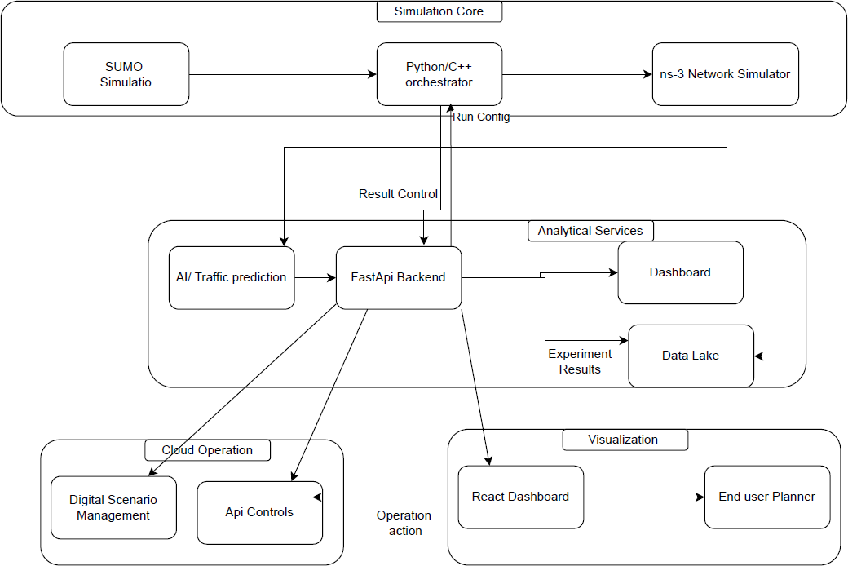

- Data Configuration/Input:
  - The user interacts with the Web Client and defines the parameters/variables for the simulation.
  - Configuration data (map, traffic density, etc.) sent to Simulation and AI Data Storage.

- Initialization:
  - The Web Client begins a new simulation via sending a request through the API Gateway to the Control Software that is connected to Traci,
  - Control Software accesses Simulation and AI Data Storage to retrieve the pre-defined vehicles, routes, map and the AI Model.
  - Configure the Simulation Software based on input data.
  - AI Model data loaded into Data Interpreter.

- Simulation Running:
  - Control Software commands SUMO to engage traffic simulation along defined routes and traffic patterns.
  - Control Software passes data from SUMO into Traci.
  - Traci simulates V2I communication between different vehicles and infrastructure.
  - Control Software passes data into Data Interpreter.

  - Analyses traffic-flow patterns and outputs probability of congestion before they occur.
  - Control Software takes preventative measures based on Data Interpreter.
  - Inform SUMO simulation to force specific cars to brake.
  - Inform Traci to issue warning messages to all nearby vehicles.
  - Adjust routes and traffic infrastructure to adjust to reduce congestion.
  - Control Software stores all information collected into Simulation Data Result Storage.

Data Display:
    - Web Client requests simulation information through API Gateway.
    - API Gateway retrieves information from Simulation Data Result Storage.
    - Data sent to Web Client.
- User can see:
  - Animated movement of vehicles on dashboard.
  - Traffic-flow visualization.
  - Congestion and collision alert messages.
  - Data displaying performance of simulation.
  - Plot of the result of the performance of the reinforcement Learning models used.

Software & Hardware Requirements

Software Requirements
Tools And Platforms
- Simulation Tools: SUMO,
- Programming & Integration: Python 3.10+, TraCI API
- AI/ML Libraries: TensorFlow / PyTorch, Scikit-Learn, Pandas, NumPy, Random Forest.
- Visualization: React.js, Grafana, FastAPI, Matplotlib
- Version Control: GitHub
- Containerization: Docker Compose

Hardware Requirements

System Setup Hardware
- Minimum: 8-core CPU, 16 GB RAM, 20 GB free disk space
- Recommended: 12-core CPU, 32 GB RAM for high-density scenarios if running other projects
- No specialized IoT or physical devices required.

Specialized Hardware and Software’s Approach 1:
- A single Virtual Machine (VM) Faster to ship, good for demos, and apply 1 or 2 scenarios concurrently.
Hardware: Development and show a small demo
- 8 core CPU, 16 GB Ram Memory, 30 GB SSD Storage Software:
- Operating System Ubuntu 22.04
- Runtime Docker Engine and Docker Compose
- Networking: Nginx
- Core Container
  - SUMO with Netedit tools: for custom integration
  - Orchestrator: Python, Tral glue, Batch Runner)
  - Fast API: Backend Api
  - React UI: Dashboard
- Control panel: managed through Google Kubernetes Engine (GKE), Amazon Elastic Kubernetes Service (EKS), and Azure Kubernetes Services (AKS)
- Work Node Pool: 4 nodes each 8 VCPU, 16 GB Memory, 100 GB SSD

Specialized Hardware
In a real-world V2I deployment, specific hardware is mandatory. The project cleverly uses software simulations to replicate the functionality of this expensive hardware, making the project feasible and cost-effective.

SUMO-Utills project | Real-world equivalent | Function
Vehicle agent in SUMO | On-Board Unit (OBU) / in-vehicle computer unit | Runs the logic inside each vehicle, receives messages, fuses sensor/GNSS data, evaluates risk, and decides whether to slow down, warn the driver, or reroute. In connected-vehicle architecture, on- board equipment provides processing, storage, sensing, and communications inside the vehicle.

Edge Nodes | Roadside Unit (RSU) | Fixed roadside device that communicates with nearby vehicles and infrastructure, such as intersections or hazard zones. In practice, RSUs are commonly used for corridor/intersection coverage and can broadcast safety-related information.
SUMO vehicle state | GNSS/GPS + IMU +  vehicle CAN/bus signals | Real vehicles do not get “perfect simulator coordinates. They estimate position and motion. from GNSS, inertial sensors, wheel speed, steering angle, and other vehicle signals. ARC-IT connected- vehicle flows explicitly include vehicle location and motion data such as position, heading, speed, and acceleration.
Communication layer between vehicles/infrastr ucture | DSRC or C-V2X  modem | This is the radio link that carries V2V/V2I messages. DSRC has long been used in U.S. connected-vehicle work, and NHTSA also notes ongoing work around emerging 5G-V2X capability.
Lane area Detector | LiDAR / radar / cameras / ultrasonic / vehicle-state sensors | These provide raw observations for risk estimation and ADAS behavior. NHTSA and IIHS both describe crash-avoidance systems as using cameras, radar, and lidar to detect nearby vehicles and hazards.
External ML controller attached to SUMO | Edge computer / ECU / ADAS domain controller | This is where your ML model would actually run in a prototype vehicle or roadside cabinet. SUMO is often connected to external control logic through TraCI or related APIs rather than embedding all intelligence inside the simulator.
This integration is the core of "affordable virtual testing environment."

Challenges
- Synchronizing large-scale mobility and network events in real time.
- Ensuring low latency between SUMO and Netedit network
- Designing efficient Machine learning models that can run during simulation without bottlenecks.
- Data storage and visualization performance for large datasets.
- Model Accuracy vs. Computational Complexity:
  - Challenge: Creating a highly realistic simulation (with thousands of vehicles, complex driver behaviours, and precise network conditions) requires immense computational power. There is a constant trade-off between the accuracy of the simulation and the time it takes to run it.
  - The Project’s Hurdle: The ML algorithm for collision anticipation is only as good as the data it’s trained on. If the simulated traffic patterns or driver behaviours are not realistic, the predictions will not be reliable for real-world application.
- Integration Complexity:
  - Challenge: The project relies on the seamless integration of multiple software platforms (e.g., SUMO for traffic, NS-3 for networking, and a Python environment for the ML model). Ensuring they communicate in real-time, sharing data correctly (e.g., vehicle position from SUMO to NS-3, and delay from NS-3 back to SUMO), anremainingin synchronized is a significant software engineering challenge.
- Standardization of V2X Messages:
- Challenge: The real world uses standardized message sets like SAE J2735 (Basic Safety Messages - BSM, Signal Phase and Timing - SPaT). Your simulation must implement these message standards to be credible. Designing and correctly interpreting these virtual messages is a non-trivial task.
- Validating the "Intelligence":
- Challenge: The core objective is to show that "intelligent communication lowers traffic and manages accidents." Proving this quantitatively is a challenge. You need to define clear metrics (e.g., average delay reduced by X%, number of stops decreased by Y%) and run controlled simulations with and without the V2X system to validate the benefits.

Future Improvements
- Digital Twin Integration:
  - Improvement: Move from a generic simulated city to a "Digital Twin" of a real-world urban area (e.g., using OpenStreetMap data for a specific city like downtown Boston). This would dramatically increase the project's relevance and allow for direct comparison of your model's recommendations with real-world traffic data.
- Incorporating Vulnerable Road Users (VRUs):
  - Improvement: Expand the simulation to include pedestrians and cyclists. Implement V2X communication to protect these VRUs, for example, by having their smartphones broadcast location data to nearby vehicles, allowing your ML model to predict and alert for potential collisions at intersections.
- Advanced AI/ML Models:
  - Improvement: Evolve from predictive modelling of congestion to using Deep Reinforcement Learning (DRL). In a DRL model, the AI agent (e.g., a traffic light controller) learns the optimal signal timing policy through trial and error, potentially outperforming pre-defined adaptive algorithms.
  - Improvement: Implement Federated Learning on simulated vehicles. This would allow vehicles to collaboratively improve the shared risk-prediction model without sharing their raw, private data, addressing a key privacy concern in real-world V2X.
- Edge Computing Scenario:
  - Improvement: Introduce a simulated "Edge Server" into the network architecture. This would allow you to test scenarios where highly computationally intensive tasks (like processing data from multiple vehicles to predict a complex multi-car collision) are offloaded from the vehicles to a nearby edge server, reducing latency for critical decisions.
- Cybersecurity and Resilience Testing:
  - Improvement: Use your simulation as a testbed for V2X security. Introduce malicious actors that send spoofed messages (e.g., a false "Deceleration Emergency" message) and develop/validate defines mechanisms that your AI can use to detect and mitigate these attacks. This is a critical real-world concern.

TimeLine

To ensure systematic progress and balanced workload distribution, the project timeline details each key activity—from early simulation setup and model design to final testing and presentation—guided by Agile planning principles.

Semester 1 Work Breakdown
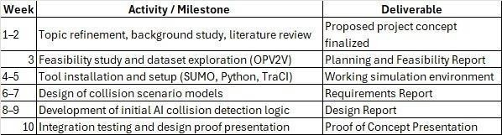
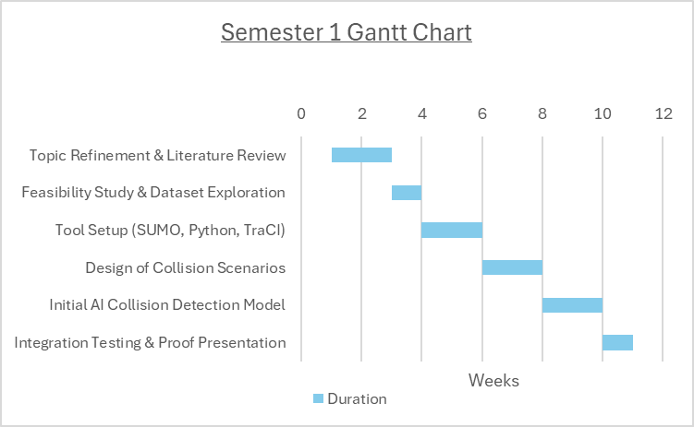

Semester 2 Work Breakdown
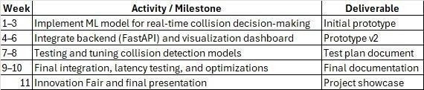

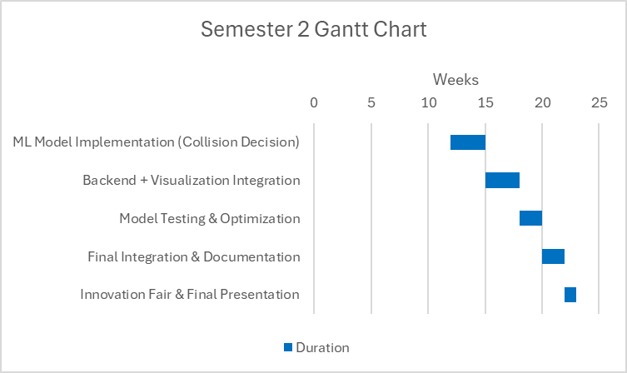
Gantt Chart
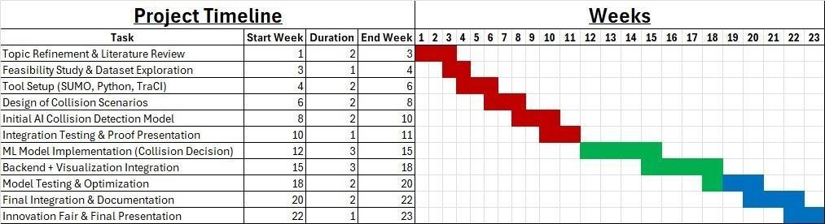

Project Management Tools to Be Used
To ensure flexibility, efficiency, and collaboration throughout the project’s lifecycle, the development team will ensure to adopt an Agile Software Development methodology combined with iterative prototyping.

Agile Framework
The project will follow a Scrum-style workflow operating in 2-week sprints. Each sprint will include:
- Sprint Planning: Define sprint goals, deliverables, and responsibilities.
- Daily/Weekly Stand-ups: Monitor progress, identify blockers, and maintain transparency.
- Sprint Review: Demonstrate progress to supervisors and gather feedback.
- Retrospective: Reflect on sprint performance and identify areas for improvement. This cyclical process promotes incremental progress, early feedback, and adaptive planning, enabling the team to respond effectively to new technical insights and challenges.

Prototyping Strategy
Functional prototypes will be developed early (within the first three weeks) too:
- Validate simulation feasibility,
- Establish the communication pipeline, and
- Test integration between SUMO, Python (TraCI), and AI modules. Subsequent prototypes will iteratively integrate:
- AI analytics modules for collision detection,
- FastAPI backend for data handling, and
- Visualization UI for interactive representation.
Each prototype iteration will undergo team and instructor reviews to ensure alignment with project objectives and key evaluation metrics (e.g., latency, throughput, collision detection accuracy).

Tools & Uses
Category | Tool(s) | Purpose/Descriptions
Version Control | GitHub | Centralized repository for source code, issue tracking
Task and Sprint Management | Jira | Create and follow sprint boards, assign tasks, progress and Agile workflow.
Communication | WhatsApp | Communication between the team and collaboration channels
Documentation and Knowledge Base | Google Drive | Store Design documents and references for easy team access
Meetings and Coordinations | Google Meet and Microsoft Tools (Outlook, calendar, Team) | Conduct meetings between the team and our Mentor as well as staying up to date with deliverables and events.




REQUIREMENTS ANALYSIS

Purpose
This System Requirements Specification (SRS) defines the technical requirements for Team DeepCyan’s project, V2Isim: A V2I AI-Powered Communication Simulator.
This document expands upon the previously submitted Planning and Feasibility Document by translating the project’s high-level goals, scope, and feasibility findings into a clear and structured set of functional and non-functional requirements.
The purpose of this System Requirements Specification is to serve as the formal reference for the analysis, design, development, testing, and validation of the system. It also provides the foundation for the next project stage, namely the System Design Document, by ensuring that all later design and implementation work remain aligned with the approved project objectives.
Any refinements or clarifications identified during the requirements phase shall be documented in this report to maintain consistency across all project deliverables.

Notation

The structure, behavior, and timeframe of the system are represented in this document and its supporting materials using a blend of traditional project management visualizations and architectural diagrams. Diagrams consist of:

The supporting materials referenced in this document include:

- System Architecture Diagrams, which illustrate the high-level static structure of the system and the interaction between major components.
- Data Flow Diagrams, which show the movement of data and control between system modules.
- Gantt Charts, which represent project milestones, development phases, dependencies, and timelines.
- Work Breakdown Structures (WBS), which identify major tasks and team responsibilities.
- Project Management Tool Mapping, which visualizes the Agile workflow and the tools used to manage the project.
- Context Diagram, which defines the system boundary and shows how the system interacts with external entities.

All requirement identifiers in this document follow the format REQ-x for functional requirements and category-based labels such as PERF-x, SEC-x, AVA-x, and CAP-x for non-functional requirements.

Scope
The V2Xsim is a Vehicle-to-Everything (V2X) communication simulation driven by AI that uses intelligent, predictive modeling to improve traffic control and road safety. In order to forecast possible traffic hazards and collisions, analyze traffic congestion patterns, suggest adaptive signal timings or alternate routes, and give researchers a testing environment to gauge the efficacy of V2X technology, the system simulates real-time communication between vehicles, infrastructure, pedestrians, and networks.
Vehicles and traffic signals in the real world will not be controlled by simulation. For testing, training, and analysis, it will only function in a controlled simulation environment.

Context Diagram
The context diagram defines the boundary of the V2Isim platform and shows its interaction with external actors and systems.
At a high level, the system interacts with:

- Users, including researchers, students, developers, and analysts, who configure simulations and review outputs through the web interface.
- Simulation Assets, such as map files, route files, traffic scenarios, and configuration files.
- Traffic and Communication Simulators, including SUMO and Netedit.
- AI/ML Models, which process simulation data and generate predictions.
- Storage Components, where logs, configurations, metrics, and results persisted.

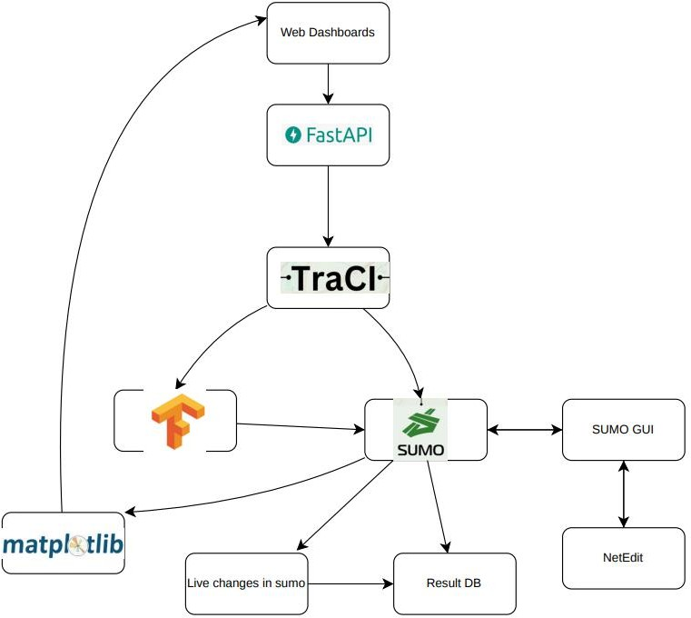

Definitions & Acronyms

Term / Acronym | Definition
V2X | Vehicle-to-Everything communication
V2V | Vehicle-to-Vehicle communication
V2I | Vehicle-to-Infrastructure communication
V2P | Vehicle-to-Pedestrian communication
V2N | Vehicle-to-Network communication
AI | Artificial Intelligence
SRS | System Requirements Specification
SUMO | Simulation of Urban Mobility traffic Simulator
Ns-3 | Network Simulator 3 for V2X Communication
TraCI | Traffic Control Interface linking SUMO and external systems
OBU | On-Board Unit (virtual vehicle node)
RSU | Roadside Unit (virtual infrastructure node)
V2Xsim | Project name for the V2X AI-Powered Communication Simulation
DeepCyan | Team name

References

Title | Author | Version | Date | Source / Location
Project Proposal | Team DeepCyan | 1.0 | 16/10/2025 | Please request a copy via email from the DeepCyan Team at: es660@uowmail.edu.au edj076@uowmail.edu.au
Planning and Feasibility Document | Team DeepCyan | 1.0 | 30/10/2025

Overview

This document defines the detailed system requirements for V2Isim and serves as the primary reference for subsequent design and implementation activities.
It should be read alongside the Planning and Feasibility Document and the Future System Design Document. Together, these reports ensure that the system is developed in accordance with the defined objectives, technical expectations, and quality requirements.

General Description

System Functions
The virtual platform shows how infrastructure and linked transportation may cooperate to reduce traffic and prevent collisions. Our system runs integrated scenarios using Python machine learning (ML) approaches, SUMO (traffic simulation), and Netedit (Vehicle network simulation).
Principal roles:

- Simulate V2I Communication
The system shall simulate communication between vehicles and roadside infrastructure to represent connected transportation behavior in a virtual environment.
- Analyze Traffic and Safety Conditions
The system shall process simulation data to estimate congestion levels, identify possible collisions, and evaluate traffic behavior under different scenarios.
- Predict Traffic Congestion and Collisions Using AI
The system should use AI and machine learning models to analyze vehicle positions, speeds, trajectories, and communication states in order to estimate congestion risk and collision probability.
- Configure and Execute Simulation Scenarios
Users shall be able to configure maps, traffic density, simulation parameters, AI settings, and run controls through a web interface.
- Automate Simulation Responses
Based on AI outputs, the system shall support actions such as rerouting vehicles, broadcasting alerts, suggesting signal changes, or applying other simulated control measures inside the virtual environment.
- Visualize and Record Results
The dashboard shall display warnings, traffic movement, performance metrics, and simulation states while also storing logs and outputs for later analysis.
These functions provide an affordable, repeatable, and safe platform for studying V2I behavior without requiring physical V2X hardware.

User Characteristics
The intended users of V2Isim include researchers, students, developers, and analysts working in intelligent transportation systems, smart mobility, V2X communication, and AI-assisted traffic analysis. Our platform makes educational applications and experimental research simpler and easier for users.
The main user groups are expected to include:

- Researchers / Developers
Users who run experiments, modify traffic or AI models, and evaluate platform behavior.
- Students
Users who access the platform for demonstrations, coursework, experimentation, or guided laboratory exercises.

- Urban Planners / Analysts
Users who evaluate traffic control ideas, policy scenarios, or infrastructure strategies using a simulated city environment.
Expected technical background includes:

- basic to intermediate familiarity with simulation systems,
- Python programming knowledge for AI and system integration tasks,
- optional machine learning knowledge for model tuning and evaluation.

The system is intended to be accessed through a web client on standard desktop or laptop hardware. No specialized real-world V2X hardware is required because communication nodes and sensors are represented in software.

General Constraints

Software Constraints
This section defines the software-related limitations and mandatory technical conditions for V2Isim.

Open-Source Licensing & Compliance

The project depends heavily on open-source tools and frameworks, including SUMO, Netedit, Python libraries, React, and Docker. The system shall be developed and used in compliance with the licenses of these technologies, including requirements for attribution, redistribution, and derivative use where applicable.
This constraint supports the project’s goal of remaining affordable and accessible, but it also requires the team to manage licensing obligations carefully if the platform is distributed beyond internal academic use.

Technology Stack Interoperability

The core architecture depends on integration between heterogeneous technologies, including SUMO for traffic simulation, Netedit for communication simulation, Python for orchestration and AI logic, and TraCI for runtime interaction with SUMO.
As a result, the project is constrained by compatibility, stability, and supported interfaces of these tools. Any major API change, deprecation, or version mismatch may affect interoperability and require redevelopment.

Programming Language Standardization

The primary implementation languages are constrained to:

- Python 3.10 or later for AI/ML logic, orchestration, and backend services.
- C++ for components that interact directly with Netedit or require native simulation integration.

This constraint improves development consistency and makes use of mature data science and web ecosystems, but it also requires team members to work across more than one programming environment.

Containerized Deployment
The deployment strategy is constrained to a containerized environment using Docker. Containerization is the preferred technical standard for maintaining consistent dependencies, configurations, and runtime behavior across development, testing, and demonstration environments.
This constraint simplifies deployment and reproducibility, but it introduces additional maintenance requirements such as Docker files, container networking, and service orchestration.

Hardware Constraints
This section defines the hardware-related limitations that affect development and runtime behavior.

Simulation Scale & Computational Resources

The complexity and realism of the simulation are constrained by available hardware, particularly CPU and memory capacity. The current baseline requirement is:
- minimum 8 CPU cores
- minimum 16 GB RAM

Higher-density scenarios may require a recommended environment of:

- 12 CPU cores
- 32 GB RAM

This constraint directly limits the number of vehicles, infrastructure nodes, and communication events that can be simulated with acceptable real-time performance.

Virtualized Development Environment

The project’s early development and demonstration environment may operate within a single virtual machine. A typical VM configuration is assumed to provide:
- 8 CPU cores
- 16 GB RAM
- 50 GB SSD storage

This improves setup consistency and ease of deployment, but reduces performance compared to native execution and may restrict high-density testing during early phases.

Absence of Specialized Physical Hardware

The project explicitly excludes real-world V2X hardware such as physical OBUs, RSUs, DSRC radios, C-V2X radios, and live traffic sensors. All such behavior shall be represented through software emulation.
This constraint is central to the feasibility of the project because it keeps costs low and simplifies experimentation. However, it also means that radio interference, physical sensor noise, and hardware- specific latency cannot be validated directly.

Assumptions & Dependencies

Assumptions

Data Fidelity

It is assumed that the data generated by SUMO and Netedit is sufficiently realistic for training, validating, and demonstrating AI/ML models related to congestion prediction and collision risk analysis.

Model Generalization

It is assumed that the AI models trained on simulated data will demonstrate meaningful principles and behaviors that are conceptually applicable to real-world V2X systems, even though the platform is not intended for direct real-world deployment.

Tool Stability

The project assumes the continued availability and relative stability of its major open-source dependencies, including SUMO, Netedit, TraCI, and relevant machine learning libraries, without major breaking API changes during the development lifecycle.

Team Proficiency

The project assumes that all team members either already possess or can quickly acquire the required technical knowledge in Python, C++, simulation systems, AI/ML model design, and software integration.

Dependencies

Software Dependencies

The system depends on the successful setup and integration of the following technologies:

- SUMO, for traffic micro-simulation.
- Netedit, for constructing and editing road networks.
- Netedit, for communication simulation.
- TraCI, for real-time interaction between SUMO and the control software.
- Python ML libraries, such as TensorFlow, PyTorch, or Scikit-learn, for predictive analytics and AI components.

Data Dependencies

The system depends on the availability of suitable map data, route definitions, and traffic demand inputs in order to construct meaningful and testable scenarios. The quality and realism of simulation outputs are directly influenced by the quality of these inputs.

Performance Dependencies

The ability to execute larger scenarios and maintain low synchronization latency depends on access to hardware that meets or exceeds the recommended baseline.

Knowledge Dependencies

Project progress depends on the team’s ability to solve integration challenges, especially those related to synchronizing SUMO and Netedit, exchanging runtime data efficiently, and designing AI models that do not introduce excessive delay.

Functional Requirements Master List
Functional Requirements Table

Req. ID | Requirement Name | Requirement Description
REQ 1 | Simulation Configurator | The system shall allow users to configure simulation parameters through a web-based dashboard.
REQ 1.1 | Simulation Parameter Configuration | The system allows users to define parameters that will be used for simulation via a web client.
REQ 1.2 | Simulation Session Starter | The system allows users to begin a new simulation via web client.
REQ 2 | Simulation Initializer

REQ 2.1 | Simulation Asset Loader | System retrieves pre-defined vehicles, routes, AI model, and other necessary data from storage.
REQ 2.2 | Simulation Software Configuration | System configures simulation software based on information provided via data retrieval.
REQ 2.3 | AI Model Startup | System loads AI model data into the interpreter.
REQ 3 | Simulation Execution | The system shall execute synchronized traffic and communication simulations with the ML model.
REQ 3.1 | Mobility Simulator | System executes SUMO software to simulate traffic data along pre-defined data.
REQ 3.2 | Network Simulator | System executes Netedit to simulate V2X communication between vehicles and infrastructure.
REQ 3.3 | Simulation Cross- Communication | System passes data from SUMO into Netedit.
REQ 4 | AI Data Interpreter
REQ 4.1 | Data Input | System passes data to AI interpreters from simulation software.
REQ 4.2 | Collision Prediction | Data interpreter identifies vehicles on crash collision course and outputs probability of impact occurring and time for collision to occur.
REQ 4.3 | Traffic Congestion Prediction | Data interpreters analyze traffic flow and outputs probability of congestion occurring.
REQ 5 | AI Intervention
REQ 5.1 | Collision Avoidance | Based on AI interpreted data, system will inform vehicles in SUMO software of measures to take to avoid crashing.

REQ 5.2 | V2X Crash Alert | Based on AI data, system will inform nearby cars of collision via warning message using Netedit.
REQ 5.3 | Traffic Congestion Reduction | Based on AI data, system will adjust routes and traffic infrastructure to lessen congestion.
REQ 6 | Data Management
REQ 6.1 | Simulation Configuration Data Storage | System stores configuration data in specified data storage location.
REQ 6.2 | Simulation Result Data Storage | System stores results of simulation in specified data storage location.
REQ 7 | Data Display
REQ 7.1 | Simulation Data Retrieval | System lets web clients retrieve simulation data via gateway.
REQ 7.2 | Animation Display | Web client dashboard displays movement of vehicles.
REQ 7.3 | Traffic Flow Display | Web client dashboard displays traffic flow.
REQ 7.4 | Warning Display | Web client dashboard displays warning messages for collisions and congestions.
REQ 7.5 | Performance Display | Web client dashboard displays performance statistics of simulation.

Functional Requirements

REQ-1: Simulation Configurator

Description
The Simulation Configurator shall enable users to define all parameters required to run a V2I simulation session, including the number of vehicles, selected road network, simulation speed, traffic density, traffic signal settings, and AI mode.

System Input
The system shall accept user-defined parameters through the web dashboard, including:

- vehicle count
- SUMO network file
- simulation duration
- simulation speed
- traffic signal settings
- AI mode selection

Display
Configuration form on the ReactJS dashboard showing input fields, dropdowns, Save and the dashboard shall provide a configuration form containing:
- input fields
- dropdown menus
- save and start controls.
- a preview area for the selected map or scenario

System Processing
The system shall validate all user inputs before starting a session.
After validation, the system shall generate a structured configuration object and prepare it for simulation startup.

System Output
The system shall generate a validated configuration file in JSON format and store it with a unique session identifier and timestamp.

Other
Configuration data shall be encoded in UTF-8 JSON format and validated for correctness, completeness, and file integrity before use.

Constraints

- The system shall support up to 200 active vehicles in the current implementation.
- Uploaded map files shall not exceed the supported file size limit.
- Invalid or incomplete configurations shall not be accepted.

Data Handling
Configurations stored as UTF-8 JSON. Parameters validated for numeric ranges and file integrity.

Error Handling
If invalid parameters are submitted, the system shall reject the configuration and display a clear validation error to the user.

REQ-2 Simulator Initializer

Description
The Simulation Initializer shall prepare the simulation environment by loading all required assets, launching the necessary modules, and synchronizing the simulation components.

System Input
The initialization process shall begin when the user starts a simulation session from the dashboard.

Display
The system shall display initialization progress indicators, including:

- loading assets
- starting SUMO
- Starting Netedit Map
- loading the AI module
- synchronization status

System Processing
The system shall:

- retrieve the selected configuration.
- load vehicles, routes, and related simulation files.
- Initially the traffic Simula simulator. the communication simulator
- load the AI model.
- establish synchronization between all active modules.

System Output
The system shall produce:

- a readiness confirmation when initialization succeeds.

- a session startup log
- error logs if initialization fails.

Other
Session data shall remain cached and available during initialization and throughout the active run.

Constraints
All simulation modules shall run in a containerized environment.
Initialization shall only complete when all required components are successfully loaded and synchronized.

Data Handling
Session configuration caught until simulation ends.

Error Handling
If initialization fails, the system shall retry startup up to three times, log the failure, and notify the operator if recovery is unsuccessful.

REQ-3: Simulation

Description
The system shall execute synchronized traffic and communication simulations in real time or accelerated time.

System Input
The system shall use the validated configuration from REQ-1 and the initialized session from REQ-2.

Display
During execution, the dashboard shall display:

- vehicle movement
- road traffic conditions
- communication activity
- simulation status
- control options such as pause, resume, stop, and speed adjustment.

System Processing
The system shall:

- running SUMO to simulate vehicle mobility
- run Netedit to simulate V2X communication.
- synchronize both environments using a control/orchestration layer.

- timestamp and exchange relevant data between modules.

System Output
The system shall produce:

- simulation logs
- network event logs.
- vehicle activity records
- structured output files for later analysis

Other
Simulation metrics shall be logged continuously with timestamps and associated with the active session identifier.

Constraints

- The current implementation shall support up to 200 active vehicles.
- The system shall support mid-run control actions such as pause, resume, and speed changes.

Data Handling
Vehicle and network metrics logged with timestamps.

Error Handling
If simulator synchronization is interrupted, the system shall pause the simulation, attempt recovery, and stop the session safely if synchronization cannot be restored.

REQ-4: AI Data Interpreter

Description
The AI Data Interpreter shall analyze synchronized simulation data to identify potential collisions and traffic congestion.

System Input
The system shall process simulation telemetry including:

- vehicle position
- speed
- direction
- latency or communication delay
- queue length
- traffic flow indicators

Display

The dashboard shall present AI analysis results through:

- collision risk indicators
- congestion indicators
- warning panels
- heatmaps or status summaries where applicable

System Processing
The system shall apply a pre-trained local AI model to simulation data in order to:

- estimate collision probability.
- estimate time-to-impact.
- estimate congestion probability or congestion index.

System Output
The system shall output structured prediction records containing:

- session identifier
- timestamp
- vehicle or area reference
- risk score
- recommended action if applicable

Other
Model version and parameters logged for reproducibility.

Constraints

- AI inference shall operate within the timing limits required for simulation responsiveness.
- Only approved local models shall be used during runtime.

Data Handling
Prediction outputs shall be cached temporarily and periodically written to persistent storage.

Error Handling
If the AI model cannot be loaded or executed, the system shall switch to a fallback rule-based detection mode and notify the operator.

REQ-5: AI Intervention

Description
The system shall support AI-driven interventions to reduce collision risk and traffic congestion, while allowing operator oversight and control.

System Input

The system shall use:

- outputs from the AI Data Interpreter
- operator commands from the dashboard

Display

The dashboard shall provide controls for:

- Approved action
- reject action.
- Request for alternative action
- review action history!

System Processing

Based on AI predictions, the system shall:

- issue warnings to relevant vehicles or infrastructure nodes.
- recommend or apply speed reduction, rerouting, or traffic signal adjustments.
- record whether an action was automatic or operator approved.

System Output

The system shall generate:

- intervention records
- Operator decision logs
- updated simulation state after the action is applied.

Other
Full traceability maintained between AI, operator, and results.

Constraints

- Intervention latency from prediction to command execution shall remain within acceptable real-time limits.
- All actions shall be traceable for review and reporting.

Data Handling

Each intervention shall be time-to-tempered and linked to:

- the triggering prediction
- the session identifier
- the affected vehicles or infrastructure components
- the final execution status

Error Handling
If an intervention command fails to execute, the system shall retry the communication, log the failure, and notify the operator.

REQ-6: Data Management

Description
The Data Management module shall store, retrieve, and organize simulation configurations, outputs, AI predictions, intervention records, and logs.

System Input
The module shall receive:

- configuration data
- simulation outputs
- AI analysis results
- operator action records
- performance metrics

Display
The dashboard shall display:

- storage status
- session history
- saved run summaries.
- availability of downloadable result files

System Processing
The system shall:

- store structured records in a database.
- archive detailed results in JSON or CSV format.
- maintain session metadata and timestamps.
- support version tracking of saved runs.

System Output
The system should provide persistent records for:

- simulation configurations
- simulation results
- AI outputs
- intervention logs
- summary metrics

Other
Backups directory.

Constraints

- Total storage shall remain within the defined project storage budget.
- Older logs may be archived or purged according to retention policy.

Data Handling

- Structured records shall be stored in PostgreSQL.
- Large result files and logs may be stored as archived JSON/CSV outputs.
- Records shall be linked using session identifiers and timestamps.

Error Handling
If database connectivity fails, the system shall temporarily cache data locally and retry synchronization at scheduled intervals.

REQ-7: Data Display

Description
The Data Display module shall provide real-time and post-run visualization of simulation behavior, AI predictions, warnings, and performance metrics.

System Input
The module shall retrieve data from:

- database records
- live backend feeds
- simulation status streams

Display

The dashboard shall provide:

- live map-based visualization
- vehicle activity display
- traffic flow display
- warning messages
- congestion or collision indicators
- charts and summary statistics
- downloadable reports

System Processing

The backend shall stream or retrieve data and deliver it to the front end for live rendering and historical analysis.

System Output
The system shall provide:

- interactive views
- charts and dashboards
- downloadable summaries
- screenshots or reports where supported

Other
Dashboard adjusts refresh rate based on latency.

Constraints

- The system shall support up to 7 concurrent users in the current implementation.
- Real-time updates shall occur at a frequency appropriate for smooth monitoring.

Data Handling
If live streaming fails, the system shall fall back to polling or cached retrieval and notify the operator of reduced update mode.

Error Handling
If WebSocket fails, the system switches to HTTP polling and alerts the operator.

External Interface Requirements

Data Interfaces
Interface Name | Description | Data Format | Protocol/Method
Simulation Configuration Interface | This interface Accepts initial simulation parameters such as traffic level, routes, and map files. | .net.xml (SUMO network), rou.xml (SUMO routes), JSON/YAML  config files | Files are uploaded through Web Client; API (REST)

Inter-Simulator Synchronization Interface | Data is exchanged in real time between SUMO traffic simulator and the Netedit network simulator for coordination of V2X communication and vehicle mobility. | TraCI Protocol Messages, Custom Socket Data | TraCI (TCP), Custom Socket Connection
AI Analytics Data Interface | This is the interface for the Data Interpreter Module, it obtains vehicle telemetry in real time (like the location, path, speed) and then provides predictions (like collision and traffic chances) | Structured Data Frames (Pandas), JSON | In-process Python function calls, Inter- Process Communication (IPC)
Results Storage & Retrieval Interface | This is the interface for storing the simulation output data (like vehicle path, records of events, performance) and for access to visualize and analyse. | JSON, CSV, Time-  Series Database Format | Database Queries, REST API Calls

User Interfaces
Interface Name | Description | Technology
Main Simulation Dashboard | This is a primary GUI for allowing users to set simulations, initiate runs and analyse results in real time. | React.js, HTML5, CSS3, JavaScript
Simulation Control Panel | This is a specific panel inside the dashboard for start, pause, stop and to reset simulations. | React.js Component with REST API backend (FastAPI)
Real-Time Visualization Canvas | This is a graphical and animation that displays vehicle motion on maps, traffic flow, and warns of any traffic accidents or jams. | React.js integrated with visualization libraries (e.g., D3.js, Leaflet)

Analytics & Reporting Dashboard | This is an independent section dedicated to showcase structured data, performance, charts, graphs and logs from simulation. | Grafana Dashboards, Custom React Components with Matplotlib/Plotly

Other Interfaces

Interface Name | Description | Type | Protocol
Version Control System Interface | This interface manages the source code, team collaboration, and integrating CI/CD pipelines. | Software Platform Interface | GitHub / Git
API Gateway Interface | This is a single-entry point that routes all of the external requests from the Web Client to the right backend services like data storage and control software. | Software Interface | HTTP/REST via Nginx or FastAPI
Virtual V2X Hardware Emulation Interface | This simulation platform will emulate the real world V2X hardware interfaces using software. Including OBUs, RSUs, and communication within Netedit. | Software Emulation | Netedit Network Models, SUMO Vehicle Agents
Container Orchestration Platform Interface | This is the interface with the container orchestration system that handles deployment, scaling, and the networking of microservices like SUMO, Netedit, API, Dashboard, AI Model. | Software Platform Interface | Kubernetes -API (if used on GKE/EKS/AKS)

Non-Functional Requirements

System Performance
Req. ID | Description | Target / Response Time
PERF-1.1 | Operator latency when navigating dashboard components (e.g., switching tabs, viewing charts). | ≤ 1 second

Req. ID | Description | Target / Response Time
PERF-1.2 | Initiating a new simulation or applying updated configuration parameters. | ≤ 3 seconds
PERF-1.3 | Executing medium-complexity simulation runs (≤ 500 vehicles, moderate network size). | ≤ 5 seconds startup time
PERF-1.4 | Full integration runs between SUMO and Netedit with real-time AI inference. | Real-time data sync latency ≤ 200 ms
PERF-1.5 | Dashboard visualization refresh rate during simulation playback. | ≥ 10 frames per second
PERF-1.6 | System throughput for simulation logs and AI outputs. | ≥ 5 000 records per minute
The system should run smoothly and update in real time so users can see what’s happening without delay. Using Docker and cloud tools helps manage resources better and keeps everything consistent between runs.

Information Security
Req. ID | Description
SEC-1.1 | All communication between client and backend services shall be protected using secure transport protocols. HTTPS/TLS 1.3.
SEC-1.2 | User authentication and authorization shall be enforced using role-based access control.
SEC-1.3 | The system shall not collect or retain personally identifiable information or external live sensor data unless explicitly approved for future extensions.
SEC-1.4 | Containerized services shall be isolated to reduce cross-service exposure.
SEC-1.5 | Secrets and environment variables shall be protected using secure configuration management.
SEC-1.6 | The platform shall comply with applicable institutional and open-source usage requirements.
Because the project is intended primarily for simulation and research, security measures should focus on privacy, service isolation, controlled access, and protection of stored configurations and results.

Availability
Req. ID | Description
AVA-1.1 | The system shall remain operational for at least 90% of scheduled demonstrations and evaluation periods.
AVA-1.2 | Failed services shall be restartable within 30 seconds and were supported by the container environment.
AVA-1.3 | The system shall support pause and resume functionality without loss of session data.
The project should always be available when needed for testing or demos. If something goes wrong, the containers or services restart automatically so the team doesn’t have to fix them manually.

Capacity
Req. ID | Description
CAP-1.1 | The current implementation shall support simulations of approximately 50 to 200 vehicles and 8 to 16 roadside units.
CAP-1.2 | A single simulation run may generate up to 1 to 2 GB of logs and result data.
CAP-1.3 | The system should maintain acceptable performance during simulation runs lasting 10 to 15 minutes.
CAP-1.4 | The platform shall operate on a standard workstation or virtual machine with approximately 8 CPU cores and 16 GB RAM minimum.
Capacity figures derive from the project’s defined hardware baseline (8-core CPU / 16 GB RAM minimum, 32 GB recommended). Scaling is achieved horizontally through Kubernetes node pools, ensuring predictable performance for educational and research usage.




DESIGN DOCUMENT

Introduction

Purpose
The purpose of this Software Design Document (SDD) is to describe the internal design of V2ISim, an AI-powered traffic simulation platform for junction congestion analysis and adaptive signal-control experimentation.
This document translates the approved requirements into a concrete technical design that can guide implementation, testing, maintenance, and future extension. It explains the architecture, major software components, data structures, control flow, deployment structure, and user interface design of the system.
The Software Design Document is intended for:

- developers implementing or maintaining the system,
- testers validating functionality and performance,
- supervisors and academic evaluators reviewing the design quality,
- and future contributors extending the platform.

This document is aligned with the previously defined System Requirements Specification and focuses on the current implemented system, not a hypothetical future platform.

Scope of the Project
V2ISim is a web-based simulation platform that allows a single operator or researcher to select a predefined traffic scenario, choose an AI control model, launch a SUMO simulation through FastAPI and TraCI, and view live and post-run congestion metrics through a browser dashboard.
The current version of the system is focused on:

- traffic congestion prediction and handling at multiple junctions,
- traffic signal interaction,
- comparison of reinforcement learning models,
- and visual and analytical review of simulation results.

The system currently supports:

- three predefined SUMO simulation scenarios,
- two AI control models: Q-Learning and Deep Q-Learning,
- runtime controls such as speed adjustment and vehicle addition/removal,
- storage of simulation outputs in CSV and JSON time-series files,
- and browser-based result visualization.

The current scope excludes:

- NetEdit-based network simulation,
- PostgreSQL or other database persistence,
- physical V2X hardware,
- live real-world traffic control,
- multi-user collaboration,
- and non-web client interfaces.

Design Goals
The design aims to satisfy the following goals:

- provide a clear and modular architecture,
- support repeatable simulation-based traffic experiments,
- enable comparison of Q-Learning and Deep Q-Learning control behaviour,
- maintain consistency with the SRS,
- support simple single machine containerized for deployment,
- and allow future extension without redesigning the full system.

System Overview

V2ISim is an interactive traffic simulation platform built around a browser dashboard, a FastAPI backend, SUMO executed through TraCI, and reinforcement learning-based traffic control logic.
The system works as follows:

- A user logs into the dashboard.
- The user selects one of three predefined simulation scenarios.
- The user chooses an AI model:
  - Q-Learning, or
  - Deep Q-Learning.
- The user starts the simulation from the Scenario Setup page.
- The frontend sends the request to the FastAPI backend.
- FastAPI launches SUMO through TraCI and initializes the selected control logic.
- During simulation, the backend gathers state and metric data.
- The dashboard displays live simulation status and performance indicators.
- At the end of the run, the system stores results as CSV/JSON time-series outputs.
- The user reviews analytics and reports from the dashboard.

The platform is intended for a single operator/researcher using a single machine containerized for deployment. It uses HTML, CSS, JavaScript, and Python for the dashboard and backend logic.
SUMO is used for traffic mobility simulation, while NetEdit is used offline to create and modify road networks and traffic maps. TraCI acts as the execution bridge between the backend and SUMO.

The main outputs of the current system are:

- total queue length,
- cumulative reward,
- Waiting time,
- throughput,
- and number of vehicles.

System Architecture

Architectural Design

Architectural Style

The architecture of V2ISim follows a layered modular architecture with a central orchestration backend.
The main layers are:

- Presentation Layer
- Application/Control Layer
- Simulation and AI Layer
- Data Output Layer

This structure was chosen because it keeps the web dashboard, simulation control, AI logic, and result storage clearly separated while remaining simple enough for a capstone-scale implementation. This is consistent with the modular approach already reflected in your prior design draft.

High-Level Subsystems

The system consists of the following major subsystems:

- Web Dashboard Subsystem

Responsible for user interaction through the browser. Responsibilities:
  - operator login,
  - scenario selection,
  - AI model selection,
  - simulation control,
  - live metric display,
  - report and analytics display.

Technologies:

  - HTML
  - CSS
  - JavaScript

- FastAPI Backend Subsystem

Acts as the central integration and control layer. Responsibilities:
  - receiving frontend requests,
  - validating scenario and model selections,
  - launching and controlling simulation runs,
  - interfacing with TraCI,
  - collecting metrics,
  - storing outputs,
  - returning data to the dashboard.

- Simulation Control Subsystem Coordinates the simulation lifecycle. Responsibilities:
  - starting SUMO,
  - managing simulation stepping,
  - pausing/resuming/stopping runs,
  - changing execution speed,
  - adding/removing vehicles during runtime,
  - synchronizing AI actions with SUMO state.

- AI Control Subsystem

Provides traffic-control intelligence. Responsibilities:
  - loading the selected model,
  - reading junction and traffic state,
  - evaluating rewards,
  - selecting signal control actions,
  - updating policy decisions.

Supported models:

  - Q-Learning
  - Deep Q-Learning

- SUMO/TraCI Integration Subsystem Bridges the application to the traffic simulator. Responsibilities:
  - launching SUMO using the selected scenario,
  - exchanging simulation state with the backend,
  - controlling traffic lights,
  - reading vehicle counts, queues, and waiting times,
  - applying runtime interventions.

- Output Storage Subsystem

Stores simulation results and exports them for review. Responsibilities:
  - writing CSV time-series files,
  - writing JSON summary or metadata files,
  - preserving run-level analytics,
  - making outputs available to the dashboard.

Architectural Flow

The main subsystem collaboration is:

- The user interacts with the Web Dashboard.
- Dashboard sends requests to FastAPI.
- FastAPI calls the Simulation Control layer.
- Simulation Control launches SUMO through TraCI.
- AI Control reads simulation state from TraCI-backed runtime data.
- AI Control selects actions for junction control.
- Simulation Control applies actions to SUMO.
- Metrics are collected continuously.
- Results are written to CSV/JSON.
- Dashboard displays live and post-run outputs.

This flow gives the backend a central orchestration role while keeping the frontend lightweight and the simulation logic isolated.

Decomposition Description

Subsystem Model

At an object and component level, the system is decomposed into the following main subsystems:

  - User Interface Subsystem
  - Authentication Subsystem
  - Scenario Management Subsystem
  - Simulation Controller Subsystem
  - SUMO/TraCI Adapter Subsystem
  - AI Model Subsystem
  - Metrics and Analytics Subsystem
  - Output Export Subsystem

Main Components by Subsystem
- User Interface Subsystem Main Dashboard Page
Provides a high-level summary of the system and access to all pages. Responsibilities:
  - showing recent run summaries,
  - showing quick navigation,
  - displaying high-level status.

Login Page
Allow the operator to authenticate before using the system. Responsibilities:
  - user credential entry,
  - session initiation.

Scenario Setup Page
Allow the operator to choose:
  - one of three predefined scenarios,
  - one of two AI models,
  - and initial run settings.

Responsibilities:

  - scenario selection,
  - model selection,
  - start command,
  - initial parameter setup.

Live Simulation Page
Displays simulation activity and real-time metrics. Responsibilities:
  - show run status,
  - show current vehicle counts,
  - show queue and waiting behaviour,
  - expose runtime controls.

Analytics/Reports Page
Displays post-run analytics from stored output files. Responsibilities:
  - graphing time-series results,
  - showing summary KPIs,
  - enabling review of generated outputs.
- Authentication Subsystem Auth Controller
Handles login request processing. Responsibilities:
  - validating operator credentials,
  - creating session state,
  - controlling dashboard access.

Session Manager
Tracks whether the operator is authenticated. Responsibilities:
  - session creation,
  - session validation,
  - logout handling.
- Scenario Management Subsystem Scenario Registry
Maintains the set of three predefined scenarios. Responsibilities:
  - listing available scenarios,
  - returning scenario configuration details,
  - mapping UI selection to SUMO config files.

Model Registry
Maintains the available AI models. Responsibilities:
  - listing supported models,
  - loading model metadata,
  - validating model selections.

- Simulation Controller Subsystem

Simulation Controller Central backend coordinator. Responsibilities:
  - starting and stopping runs,
  - calling the scenario registry,
  - selecting the model,
  - initializing TraCI,
  - collecting metrics,
  - sending data to the frontend.

Runtime Command Handler
Processes live commands from the dashboard. Responsibilities:
  - speed up simulation,
  - slow down simulation,
  - add vehicles,
  - remove vehicles.

Run State Manager Tracks active run state. Responsibilities:
  - run status,
  - elapsed time,
  - selected scenario,
  - selected model,
  - output path,
  - live metric cache.
- SUMO/TraCI Adapter Subsystem TraCI Adapter
Encapsulates communication with SUMO. Responsibilities:
  - launching SUMO,
  - stepping the simulation,
  - reading current state,
  - applying signal-control actions,
  - adding/removing vehicles.

Junction State Reader
Builds state data for multiple junctions. Responsibilities:
  - reading queue lengths,
  - reading waiting time indicators,
  - reading active vehicle counts,
  - preparing state vectors for the AI controller.

Traffic Light Controller Applies selected actions. Responsibilities:
  - switching phases,
  - extending or shortening signal timing,
  - tracking the active phase state.

- AI Model Subsystem QLearning Controller
Implements agent-based Q-Learning logic. Responsibilities:
  - read current state,
  - choose action,
  - update Q-values,
  - compute reward.

DQL Controller
Implements Deep Q-Learning logic. Responsibilities:
  - load trained network or model state,
  - read current state,
  - choose action,
  - computing reward,
  - update policy depending on implementation mode.

Reward Evaluator
Computers are the reward used by the active model. Possible inputs:
  - total queue length,
  - Waiting time,
  - throughput,
  - number of vehicles.
- Metrics and Analytics Subsystem Metrics Collector
Captures live run metrics at each step. Responsibilities:
  - total queue length,
  - cumulative reward,
  - Waiting time,
  - throughput,
  - number of vehicles.

Analytics Processor
Computes summary values for display. Responsibilities:
  - aggregate totals,
  - averages,
  - max/min values,
  - trend preparation for charts.
- Output Export Subsystem CSV Exporter
Writes time-series data to CSV.

JSON Exporter
Writes run metadata and summary data to JSON.

Output Manager
Organizes file paths and run folders. Responsibilities:
  - create run IDs,
  - maintain output directories,
  - expose output files to reports page.

Design Rationale

Reasons for the Chosen Architecture

Separation of Concerns

The design separates user interaction, simulation control, AI logic, and data export into different components. This improves clarity, supports debugging, and makes the code easier to maintain. This principle was already present in your earlier SDD structure and remains suitable here.
Alignment with Current Implementation

The design describes the system you have:

  - web dashboard,
  - FastAPI backend,
  - TraCI-controlled SUMO execution,
  - Q-Learning and Deep Q-Learning models,
  - and CSV/JSON storage.

This prevents mismatch between the SDD and the implemented system.

Support for Runtime Interaction

The architecture includes explicit runtime control paths so the user can:

  - change speed,
  - add vehicles,
  - remove vehicles, during a live run.
This is important because runtime control is part of the intended current behaviour.

Modularity for Model Comparison

Keeping Q-Learning and Deep Q-Learning in separate controller components makes model comparison easier and allows new models to be added later with minimal impact.

Alternatives Considered

ns-3-Based Communication Simulation

An earlier project direction included network-layer simulation concepts, but the final current design does not use ns-3. The current system focuses on traffic control and congestion handling through SUMO, NetEdit-generated maps, and reinforcement learning-based junction control.
Database-Driven Persistence

A PostgreSQL-backed storage design was considered in broader requirements thinking, but the current implementation uses CSV and JSON output files instead to reduce complexity and match the actual system scope.

Deployment Microservices

A multi-service deployment would increase complexity and is unnecessary for a single-machine research prototype. A single FastAPI-centred architecture is more appropriate.

Trade-offs

Simplicity vs Scalability

The single-machine architecture is easier to implement and deploy, but less scalable than a distributed architecture.
File Storage vs Database Queries

CSV/JSON storage is lightweight and easy to inspect, but weaker than a database for complex querying and long-term management.

Real-Time Control vs Architectural Complexity

Supporting live control actions increases state-management complexity, but it is valuable for experimentation and demonstrations.

Data Design

Data Description
The system manages data in four broad categories:

- Input Configuration Data

Data selected before the simulation starts. Examples:
  - scenario ID,
  - SUMO configuration file path,
  - selected AI model,
  - initial speed mode,
  - initial vehicle settings.

Storage:

  - predefined configuration files,
  - static scenario metadata,
  - temporary in-memory request objects.

- Runtime Simulation Data

Data generated continuously during the simulation. Examples:
  - current step,
  - queue length at each junction,
  - Waiting time,
  - current throughput,
  - number of active vehicles,
  - active signal phase,
  - selected action,
  - reward value.

Storage:

  - RAM / in-memory structures.

- AI State Data

Data used by the reinforcement learning controller. Examples:
  - state vector,
  - selected action,
  - reward,
  - Q-table values for Q-Learning,
  - neural network state or predictions for Deep Q-Learning,
  - cumulative reward.

Storage:

  - in-memory objects during runtime,
  - optional model files outside active run scope.

- Output Data

Persistent data written after or during execution. Examples:
  - time-series CSV,
  - JSON summary,
  - run metadata,
  - chart-ready analytics values.

Storage:

  - local filesystem.

This structure follows the same general pattern as your earlier data design draft, but it has been corrected to match the final V2ISim scope rather than the older V2V/networking-oriented design.

Data Dictionary

Table 1: Configuration Data

Name | Type | Description
Scenario_Config | JSON / internal config object | Contain scenario selection, model selection, and run parameters

SUMO_Config | . sumocfg | SUMO simulation configuration file for a predefined scenario
Network_File | .net.xml | SUMO road network file created or edited with NetEdit
Route_File | . rou.xml | SUMO route and traffic demand definition
AI_Model_Config | JSON / model metadata | Describes whether Q-Learning or Deep Q-Learning is selected

Table 2: Runtime Data

Name | Attribute | Type | Description
Vehicle_State | vehicle_id | String | Unique identifier of a vehicle
Vehicle_State | position | Tuple / object | Current location on the map
Vehicle_State | speed | Float | Current speed
Vehicle_State | waiting_time | Float | Current waiting time
Junction_State | junction_id | String | Unique junction identifier
Junction_State | queue_length | Integer / Float | Number or magnitude of queued vehicles
Junction_State | phase | String / Integer | Current traffic signal phase
RL_State | state_vector | Array / list | AI input state for decision making
RL_State | action | Integer / String | Chosen control action
RL_State | reward | Float | Reward value at the current step
RL_State | cumulative_reward | Float | Running total reward
Run_Status | sim_time | Float | Current simulation time

Run_Status | vehicle_count | Integer | Number of active vehicles
Run_Status | throughput | Float | Measure of completed or moving traffic flow

Table 3: Output Data

Name | Attribute | Type | Description
TimeSeries_Output | total_queue_length | Float | Queue length over time
TimeSeries_Output | cumulative_reward | Float | Cumulative reward over time
TimeSeries_Output | waiting_time | Float | Waiting time for metric over time
TimeSeries_Output | throughput | Float | Throughput over time
TimeSeries_Output | number_of_vehicles | Integer | Vehicle count over time
Run_Summary | scenario | String | Selected scenario name
Run_Summary | model | String | Selected AI model
Run_Summary | run_id | String | Unique run identifier
Run_Summary | output_files | List | Associated CSV/JSON output files

Data Storage Model
The current system uses file-based storage rather than database storage. Storage design:
  - Each run receives a unique run identifier,
  - time-series data is written to CSV,
  - summary or metadata is written to JSON,
  - outputs are grouped by scenario and run,
  - reports page reads from generated files.

This matches the current implementation choice of CSV/JSON over PostgreSQL.

Component Design

Web Dashboard Component
The web dashboard provides all operator-visible interaction. Functions:
  - Log,
  - scenario selection,
  - model selection,
  - live control,
  - analytics display.

Inputs:

  - user commands,
  - live backend state,
  - stored output files.

Outputs:

  - start/pause/stop/control commands,
  - displayed metrics and charts.

FastAPI Backend Component
This is the central application component. Functions:
  - expose routes/endpoints,
  - validate requests,
  - manage active simulation session,
  - coordinate simulation control and outputs.

TraCI Integration Component
This component launches and controls SUMO. Functions:
  - open simulation connection,
  - step the simulator,
  - read state from SUMO,
  - Write signal or vehicle commands back.

AI Control Component
This component contains the selected reinforcement learning controller. Functions:
  - build state representation,
  - Computer actions,
  - computing reward,
  - support Q-Learning and Deep Q-Learning model selection.

Metrics Component
This component transforms runtime state into dashboard-visible analytics. Functions:
  - collect time-series values,
  - prepare summary metrics,
  - feed graphs and reports.

Export Component
This component persists outputs. Functions:
  - CSV generation,
  - JSON generation,
  - output organization by scenario and run.

Human Interface Design

Overview
The user interface is designed for a single operator/researcher. It emphasizes clarity, experiment control, and visibility into traffic and model behaviour.
The interface must make it easy to:

  - Log in,
  - Select a scenario,
  - choose a model,
  - launch the simulation,
  - monitor live traffic behaviour,
  - change runtime controls,
  - and review final analytics.

Main Pages Login Page Purpose:
  - authenticate the operator before access. Main elements:
  - username field,
  - password field,
  - login button.

Dashboard Page
Purpose:
  - provide high-level navigation and current system summary. Main elements:
  - navigation bar,
  - recent run summaries,
  - quick access to Scenario Setup,
  - system status widget.

Scenario Setup Page
Purpose:
  - prepare a simulation before launch. Main elements:
  - scenario selector with 3 predefined scenarios,
  - model selector with Q-Learning and Deep Q-Learning,
  - configuration summary,
  - start button.

Live Simulation Page
Purpose:
  - display live simulation and allow runtime interaction. Main elements:
  - simulation status panel,
  - active metrics panel,
  - controls for speed up / slow down,
  - add vehicle button,
  - remove vehicle button,
  - live map/simulation view,
  - junction analytics display.

Analytics/Reports Page
Purpose:
  - review completed runs and output metrics. Main elements:
  - charts for total queue length,
  - cumulative reward,
  - Waiting time,
  - throughput,
  - vehicle count,
  - summary cards,
  - download/export links for CSV/JSON.

Interface Objectives
The interface is designed to:

  - remain simple and readable,
  - support real-time awareness,
  - allow quick runtime experimentation,
  - present analytics clearly,
  - reduce cognitive load for academic use.

UI Wireframe Descriptions

Wireframe 1: Login
Top-centred login card with username, password, and submit button.

Wireframe 2: Dashboard
Header navigation at top, summary cards beneath, recent runs or quick actions in centre area.

Wireframe 3: Scenario Setup
Left panel for scenario selection, right panel for model selection and run options, bottom start button.

Wireframe 4: Live Simulation
Top bar with run status; centre main map/visual area; right-side metrics panel; lower control strip for speed and vehicle commands.

Wireframe 5: Analytics/Reports
Grid of KPI cards at top; charts below; file download section at bottom.

Design Diagrams

System Architecture Diagram Description
The architecture diagram should show:

  - browser dashboard,
  - FastAPI backend,
  - TraCI adapter,
  - SUMO simulator,
  - AI model module,
  - CSV/JSON output storage.

Flow:
User → Dashboard → FastAPI → TraCI → SUMO
SUMO state → FastAPI → AI Model → control action → SUMO FastAPI → CSV/JSON → Reports page

Component Diagram Description
Main components:

  - Authentication
  - Dashboard UI
  - Scenario Manager
  - Simulation Controller
  - TraCI Adapter
  - QLearning Controller
  - DQL Controller
  - Metrics Collector
  - Output Manager

Sequence Diagram Description
Main sequence for starting a run:
- User logs in.
- User selects scenario and model.
- Dashboard sends start requests to FastAPI.
- FastAPI validates input.
- Simulation Controller loads scenario.
- TraCI Adapter launches SUMO.
- AI model initializes.
- Simulation loop begins.
- Metrics are collected each step.
- Live data is returned to dashboard.
- Output files are written at running completion.

Class Diagram Description
Suggested classes:

  - UserSession
  - Scenario
  - Model Selection
  - SimulationController
  - RunState
  - TraCIAdapter
  - JunctionState
  - VehicleState
  - RewardEvaluator
  - QLearningController
  - DQLController
  - MetricsCollector
  - Output Manager
  - CSVExporter
  - JSONExporter Key relations:
  - SimulationController uses TraCIAdapter, MetricsCollector, OutputManager, and one AI controller.
  - RunState aggregates JunctionState and runtime metrics.
  - Output Manager uses CSVExporter and JSONExporter.

Deployment Diagram Description
Single-machine Docker deployment with:

  - browser client,
  - FastAPI application container,
  - SUMO runtime environment,
  - local output volume for CSV/JSON,
  - local AI model files.

Data Model Diagram Description
Entities:
  - Scenario
  - Run
  - JunctionState
  - VehicleState
  - MetricRecord
  - Model Selection
  - OutputFile

Relationships:

  - one Scenario has many Runs,
  - one Run has many MetricRecords,
  - one Run produces multiple OutputFiles,
  - one Run uses one ModelSelection.

Requirements Traceability Matrix

Requirement Matrix

SRS Req. ID | Requirement Name | Description | Design Component / Module
REQ-1 | Simulation Configurator | Allows operator to choose scenario and simulation parameters through the dashboard | Scenario Setup Page, Scenario Registry, FastAPI Backend
REQ-2 | Simulation Initializer | Initializes scenario, SUMO execution, and selected AI model | Simulation Controller, TraCI Adapter, Model Registry
REQ-3 | Simulation Execution | Executes SUMO simulation with live runtime control | Simulation Controller, Runtime Command Handler, TraCI Adapter
REQ-4 | AI Data Interpreter | Interprets traffic state for congestion-related control decisions | QLearning Controller, DQL Controller, Reward Evaluator, Junction State Reader
REQ-5 | AI Intervention | Applies or displays traffic-control actions inside the simulation | Traffic Light Controller, Simulation Controller, AI Control Subsystem
REQ-6 | Data Management | Stores’ outputs and run results | Metrics Collector, Output Manager, CSV Exporter, JSON Exporter
REQ-7 | Data Display | Displays live and post- run metrics on the dashboard | Live Simulation Page, Analytics/Reports

Page, FastAPI Backend

Traceability Notes
The traceability matrix shows that every functional requirement from the SRS is addressed by one or more concrete design components. This ensures the design remains directly aligned with the requirements baseline.
In particular:

  - the configurator requirement is implemented through the web setup flow,
  - initialization and execution are owned by the backend control pipeline,
  - congestion interpretation is handled by the reinforcement learning controllers,
  - intervention is represented as simulated traffic-light control,
  - data management is implemented through CSV/JSON storage,
  - and data display is fulfilled by the live and analytics pages.es.




TEST RESULTS

Introduction
DeepCyan V2I v2.3 Demo is a smart mobility simulation platform where a user controls a Simulation of Urban Mobility (SUMO) traffic simulation through a web dashboard. The backend FastAPI + Traffic Control Interface (TraCI) runs simulation control and RL-based traffic light optimization Q- learning; optional Deep Q-learning comparison. The purpose of this test effort is to validate that the demo workflow completes a full simulation cycle less than or equal to 90 seconds under standard configurations.
The system must demonstrate stability defined as zero SUMO freezes where the simulation runs smoothly and doesn’t crash at any step. Or TraCI disconnections while handling various control behaviours (start/stop/pause/resume, speed control, and scenario switching) this must be handles quickly as well so the changes can be seen happening in the SUMO platform. Simulation step counts and vehicle densities are configurable; however, this test plan focuses on ensuring stable execution under small-to-moderate loads (10–100 vehicles) to provide a verifiable and defensible baseline for performance.

Objectives

Primary Objectives
- End-to-End Workflow Performance: System must complete a full simulation cycle within 90 seconds under standard demo configuration (1-100 vehicles, Q-learning mode).
- Simulation Stability: Traffic light phase optimization must maintain system stability, defined as zero SUMO freezes, zero TraCI disconnections, and zero RL loop terminations during execution.
- Control Reliability: Validate the following control endpoints and speed modifiers respond quickly.
  - speed up/down/custom speed.
  - /start /stop/pause /resume
  - add/remove vehicles (custom count)
  - map/scenario switching (even if currently 1 map, test the feature)
  - status endpoint
  - export results
- Compare outcomes: Baseline vs Q-learning vs Deep Q-learning (where available).

Secondary Objectives
- Basic login/signup flow works (demo access).

Scope

In Scope
- Web dashboard UI controls (start/stop/pause/resume, speed, vehicle count, map select, status, graphs, export)
- FastAPI endpoints
- TraCI control loop integration with SUMO GUI
- RL optimization Q-learning and DQN comparison
- Baseline fixed traffic signal comparison workflow
- Results/graphs generation on dashboard

Out of Scope
- Multi-user concurrency testing
- Full security penetration testing (only basic auth workflow + basic checks)
- Production deployment testing (cloud hosting, autoscaling, etc.)
- Full Prometheus/Grafana integration testing since currently “could be saved” we’ll test “export now” + optional “metrics endpoint exists” if you already have one.

Assumptions
- Simulation environment is pre-installed: SUMO, scenario files, and dependencies on the demo machine.
- Only one user operates the system during demo.
- One map is currently available; however, switching logic is still tested for stability.

Test Approach / Strategy

Testing Types Included
- Smoke Testing: Verify system starts and basic flow works.
- Functional Testing: All endpoints + UI controls + RL runs + graph display + export.
- Integration Testing: Dashboard ↔ FastAPI ↔ TraCI ↔ SUMO ↔ RL loop.
- Regression Testing: Re-test critical flow after changes.
- Usability Testing (demo-focused): Buttons, feedback messages, status visibility.
- Performance Testing (demo-focused): Run completes within ~1.5 minutes and UI remains responsive.

Manual vs Automation
- Manual: Primary for demo readiness (UI + end-to-end).
- Automation (optional/minimal):
- API-level tests for endpoints using Postman/newman or pytest.

Test Design Technique
- Risk-based prioritization:
- Start/stop/pause/resume stability.
- RL loop and traffic light phase updates
- Results graph + export.
- Vehicle operations + speed control
- Login/signup

Test Environment

Hardware/OS
- Demo PC: Windows 11 or MacOs
- Recommended: 8GB minimum RAM (for SUMO + browser + backend)

Software
- SUMO GUI installed and runnable.
- Python runtime and required packages for FastAPI + TraCI.
- Node/npm for dashboard build/dev (if running in dev mode)
- Browser: Chrome or Edge (pick one as “demo standard”)

Environment Configuration
- Known working scenario folder paths (your SUMO scenario root)
- Ports open FastAPI port, 8000; dashboard port, 5173.

Test Data
- Load Categories:
  - Small Load: 10 vehicles.
  - Medium Load (Standard): 50 vehicles.
  - Heavy Load (Stress): 100 vehicles.
- Software Prerequisite: SUMO GUI, Python (TraCI + FastAPI), and a standard browser (Chrome/Edge).
- Speed values: normal (1x), fast (2x/4x), custom values (0.5x, 3x)
- RL modes:
- Baseline fixed time
- Q-learning
- DQN

Test Case Definitions

TC-SIM-01: Start Simulation

- Objective: Validate simulation initialization.
- Steps:
- Select map scenario.
- Set vehicle count = 50.
- Click "Start".
- Expected Result: SUMO launches successfully, TraCI establishes a connection, and simulation status transitions to "Running".

TC-RL-01: Q-Learning Optimization

- Objective: Validate RL phase adaptation.
- Steps:
- Initialize simulation in Q-Learning mode.
- Monitor "Node 2" traffic light phases during vehicle buildup.
- Expected Result: Signal phases update dynamically based on detected queue lengths; no simulation freezes or TraCI disconnections occur.

TC-MET-01: KPIs / Metrics Validation

- Objective: Validate accuracy of generated statistics.
- Steps:
- Observe real-time "Queue Ratio (%)" on the dashboard.
- Cross-reference dashboard values with raw SUMO induction loop data.
- Expected Result: Queue Ratio, Average Waiting Time, and Throughput calculations match SUMO raw data precisely.

TC-UI-01: Results Visualization

- Objective: Validate performance data rendering.
- Steps:
- Complete the simulation run.
- Navigate to the results/graphing tab.
- Expected Result: Performance graphs render fully within $\le$ 2 seconds after simulation end.

Entry Criteria
- Build deployed (dashboard accessible)
- FastAPI runs without errors.
- SUMO scenario loads successfully.
- Required config paths set and verified.
- Test cases prepared and reviewed.

Exit Criteria

To conclude testing, the following measurable thresholds must be met:

- Stability: RL optimization must produce dynamic phase updates without any simulation halt or loop termination.
- Integrity: Every Export action must successfully generate a CSV/JSON file without file corruption.
- Rendering Speed: All performance graphs must render within $\le$ 2 seconds after the simulation has ended.
- Consistency: The end-to-end demo workflow must pass 3 consecutive runs without a system crash.

Test Cases

- Authentication: TC-AUTH-

TCID | Title | Steps | Expected Result | Type
TC-AUTH-01 | Signupnewuser | Openapp→Signup→enter validfields→submit | Account created redirected/loginpossible | Functional
TC-AUTH-02 | Loginvaliduser | Openapp→Login→validcredentials | Loginsuccess, dashboardloads | Smoke
TC-AUTH-03 | Logininvaliduser | Loginwithwrongpassword | Error messageshown, noaccess | Functional

- Core Simulation Controls: TC-SIM –

TCID | Title | Steps | Expected Result | Type
TC-SIM-01 | Start simulation | Set vehicles=50 →Start | SUMOstarts, status=Running, timer increments | Smoke/Integration
TC-SIM-02 | Pausesimulation | Start →Pause | SUMOsteppingstops, status=Paused | Functional/Integration
TC-SIM-03 | Resumesimulation | Pause→Resume | Steppingcontinues, status=Running | Functional/Integration
TC-SIM-04 | Stopsimulation | Start →Stop | Simulation terminates cleanly, status=Stopped | Smoke/Integration
- Speed Controls

TCID | Title | Steps | Expected Result | Type
TC-SPD-01 | Speedup | Start →speedup | Simulationrunsfaster; UI reflectsspeed | Functional
TC-SPD-02 | Speeddown | Start →speeddown | Simulationslows; UI reflects | Functional
TC-SPD-03 | Customspeedvalid | Set customspeed=3x→apply | Speedchanges, noinstability | Functional
TC-SPD-04 | Customspeedinvalid | Set customspeed=-1or text | Validationerrorshown, nochange | Functional
- Vehicle Control

TCID | Title | Steps | Expected Result | Type
TC-VHC-01 | Addvehiclesvalid | Start→add10vehicles | Vehiclecount increases, simstable | Functional/Integration
TC-VHC-02 | RemoveValleyvalid | Start→remove5vehicles | Vehiclecount decreases, simstable | Functional/Integration
TC-VHC-03 | Addvehiclesinvalid | Add-10or hugenumber | Validationerror +nocrash | Functional
- Map Switching

TCID | Title | Steps | ExpectedResult | Type
TC-MAP-01 | Loadmaplist | Openmapselector | List displays(evenif 1map) | Functional
TC-MAP-02 | Switchmapbeforestart | Select mapA→switch | Selectedmapchanges, statusready | Functional
- RL Optimization

TCID | Title | Steps | Expected Result | Type
TC-RL-01 | Q-learningrun completes | mode=Q-learning→start(50vehicles) | Run completes within1.5 min, graphs generated | Integration/Performance
TC-RL-02 | Baseline vs Q-learningcomparison | Runbaseline→savemetrics→runQ-learningsamevehiclecount | Q-learnings show improvement trend (queue/wait) or at least produce comparable metrics | Functional
TC-RL-03 | DQNrun completes(optional) | mode=DQN →start | Runcompletes(may exceed1.5min if expected) but doesn’t crash | Integration
TC-RL-04 | Baseline vs Q-learningvsDQN | Runall 3modessameconfig | Results stored/visualized clearlyand labeled | Functional
TC-RL-05 | Traffic lightupdatesapplied | Start RL→observe junction phases | Phase changesoccur as RLactionoutputs | Integration
- Results, Graphs

TCID | Title | Steps | Expected Result | Type
TC-RES-01 | Graphsdisplay after running | Runcompletes | Graphsvisiblewithcorrect labels | Usability/Functional

Traceability Matrix

ReqID | Requirement | Test Cases
FR-01 | User canlogin/signup to accessdashboard | TC-AUTH-01, TC-AUTH-02, TC-AUTH-03
FR-02 | User canstart and stopsimulation | TC-SIM-01, TC-SIM-04, TC-SIM-05, TC-SIM-06
FR-03 | Users canpauseandresumesimulation | TC-SIM-02, TC-SIM-03
FR-04 | User canchangesimulationspeed (up/down/custom) | TC-SPD-01, TC-SPD-02, TC-SPD-03, TC-SPD-04
FR-05 | User canadd/removevehicleswithcustomcounts | TC-VHC-01, TC-VHC-02, TC-VHC-03
FR-06 | User canselect/switchscenarios/maps | TC-MAP-01, TC-MAP-02, TC-MAP-03
FR-07 | Systemprovidesstatusendpoint for runtimestate | TC-RES-04
FR-08 | RLoptimization (Q-learning) controls traffic light phases | TC-RL-01, TC-RL-05
FR-09 | Baseline vs RLcomparisons are available | TC-RL-02, TC-RL-04
FR-10 | Resultsshown as graphson dashboard | TC-RES-01
FR-11 | Resultscanbeexported | TC-RES-02, TC-RES-03
NFR-01 | Runcompletes in ~1.5 minutes (Q-learningdemo run) | TC-RL-01, TC-STB-01
NFR-02 | System isstableacrossconsecutive runs | TC-STB-01
NFR-03 | UI remainsusableandrecoversfromrefresh | TC-STB-02, TC-STB-03

KPI’s / Metrics Validation
To evaluate the operational efficiency of the DeepCyan reinforcement learning models, this project utilizes a quantitative validation framework based on standard urban mobility benchmarks. The following Key Performance Indicators (KPIs) are recorded during each simulation cycle to measure the impact of intelligent signal control on traffic throughput and vehicle delay.
  - Throughput Validation: Verify the system accurately counts the total number of vehicles that exit the road network per time unit.
  - Queue Ratio Accuracy: Validate that the real-time Queue Ratio (%) calculation matches the specific lane-area detector data from SUMO to ensure the RL model is receiving accurate state information.
  - Average Waiting Time: Confirm the recorded delay for each vehicle matches the waiting time data provided by the TraCI API during simulation.
  - Stability Benchmark: Ensure RL phase updates are executed without causing simulation halts, verifying the robustness of the integrated logic.




SCREENSHOTS

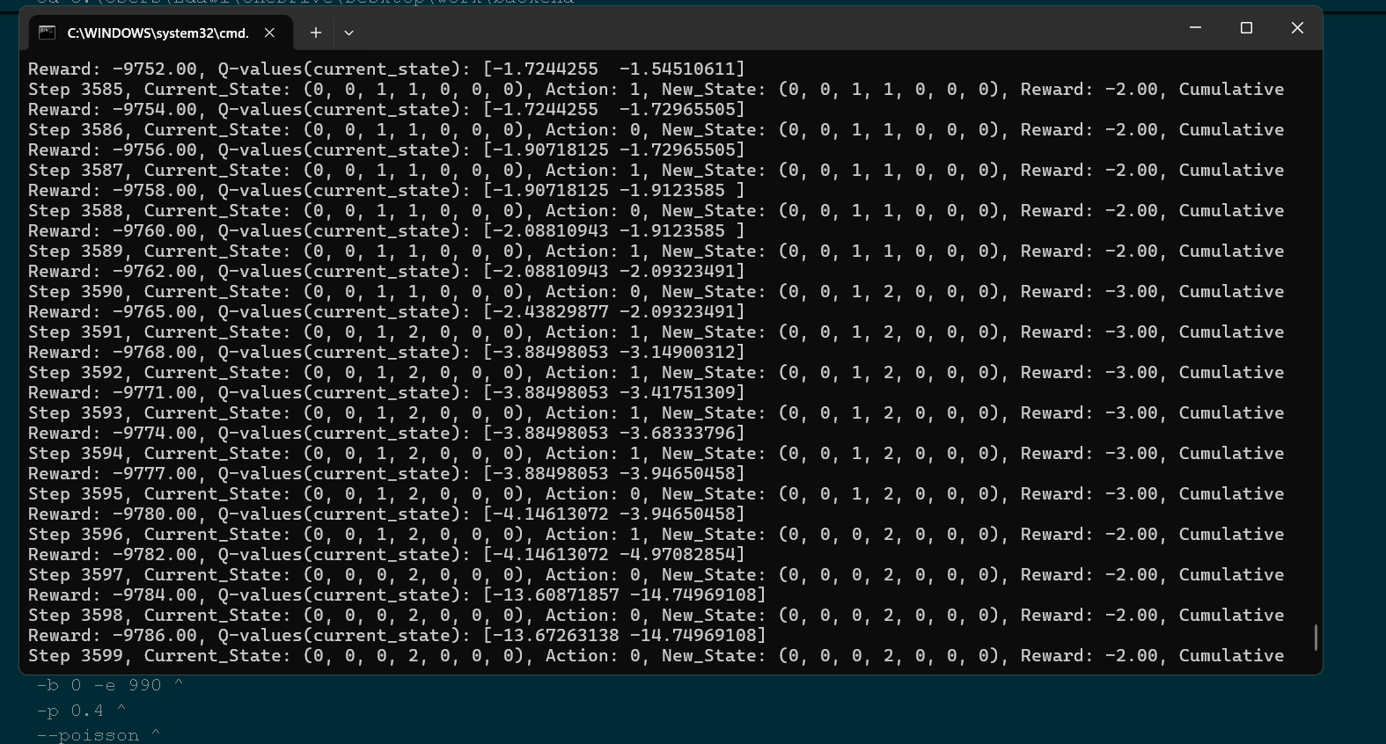
RL running on the system.
Image of Map 1
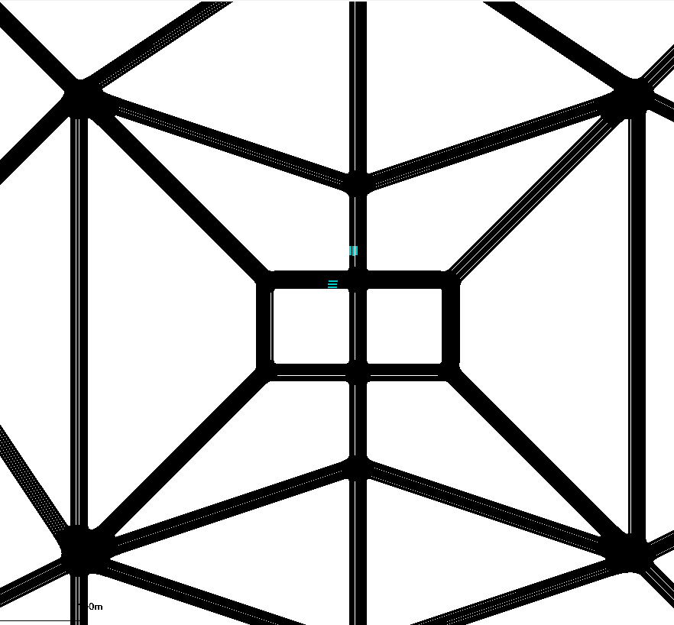
Map 2

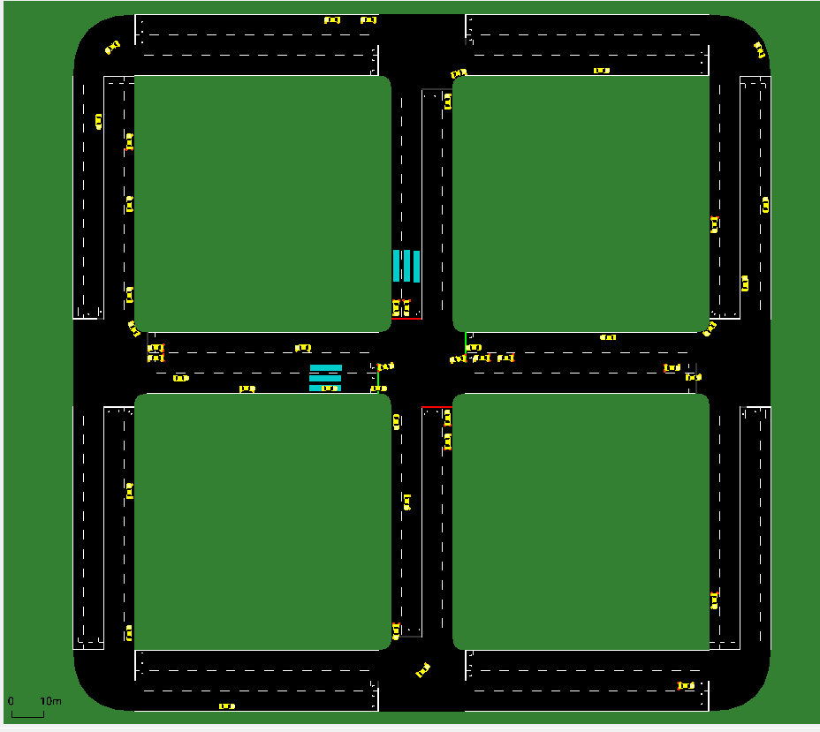
Map 3

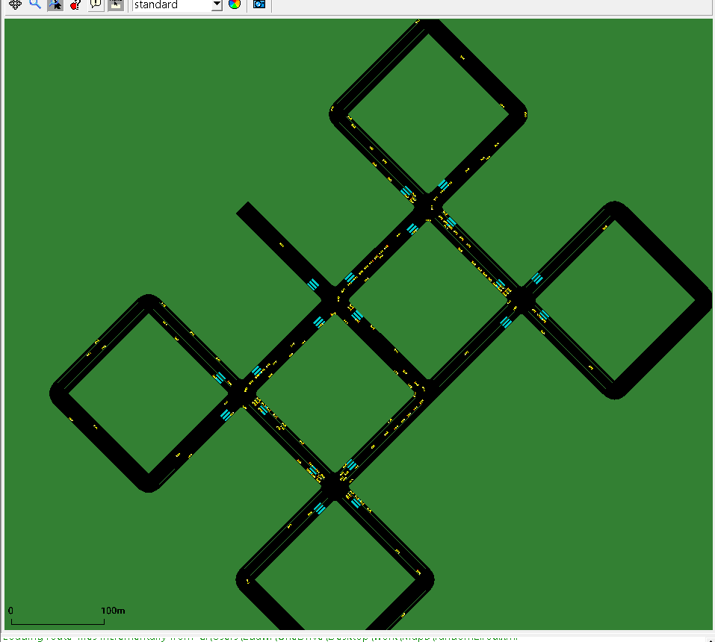
Map 4

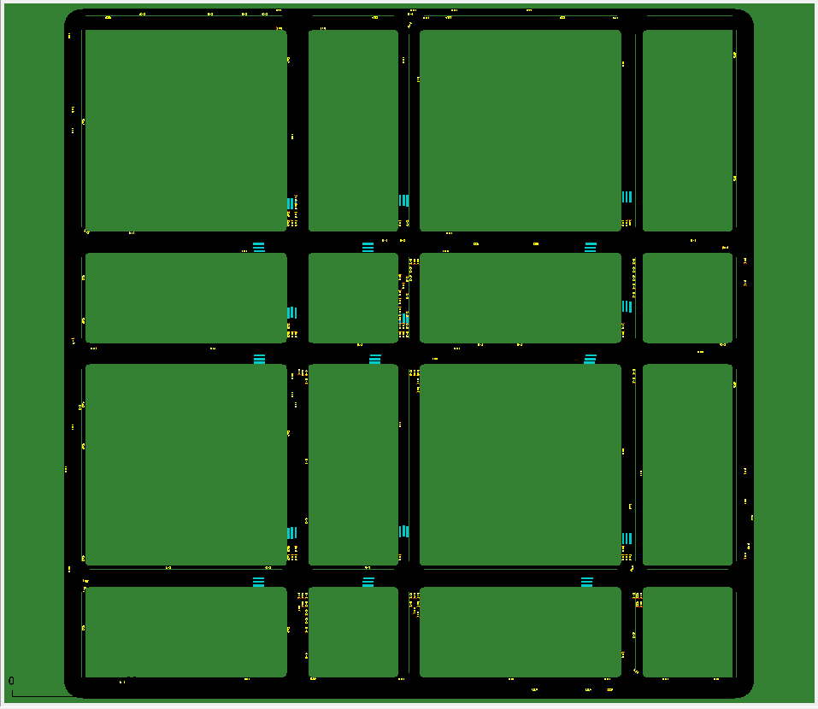
Map 5

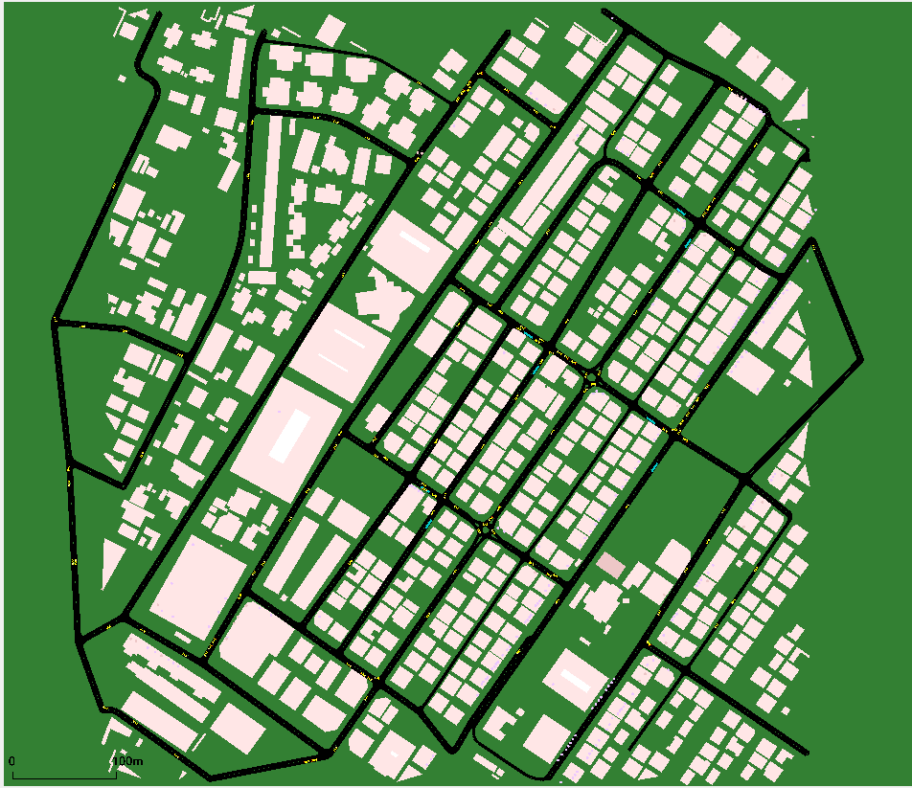

Result of Map 1 showing that the RL performance is better that the fixed time signals.
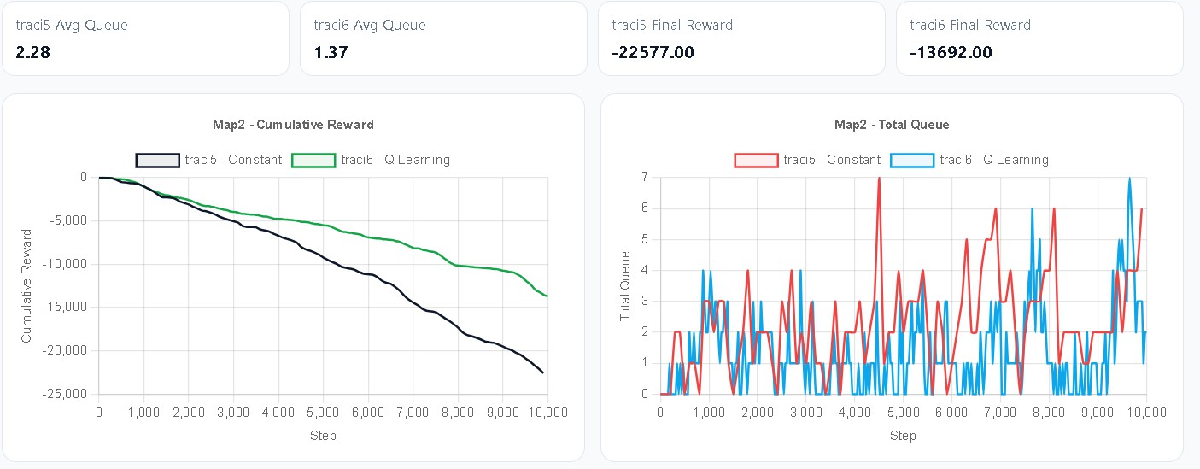

Dashboard page

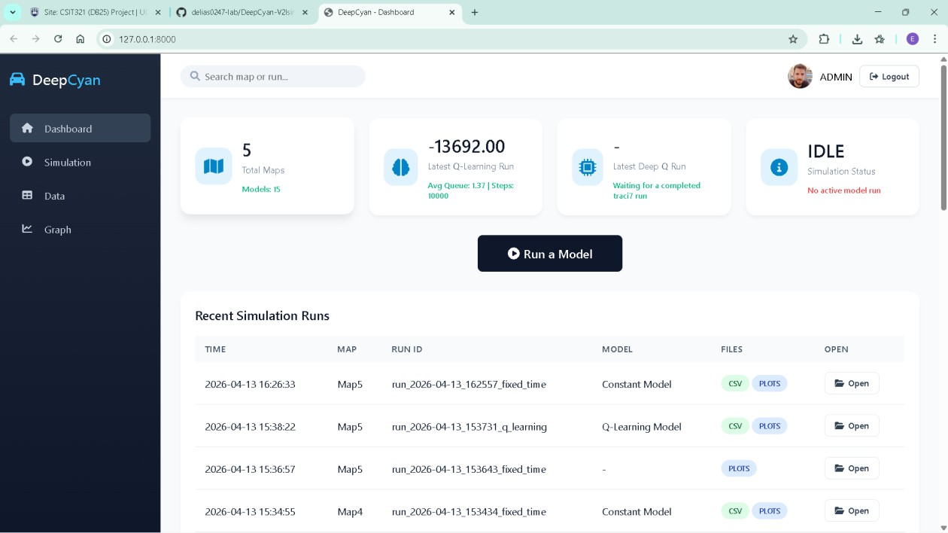
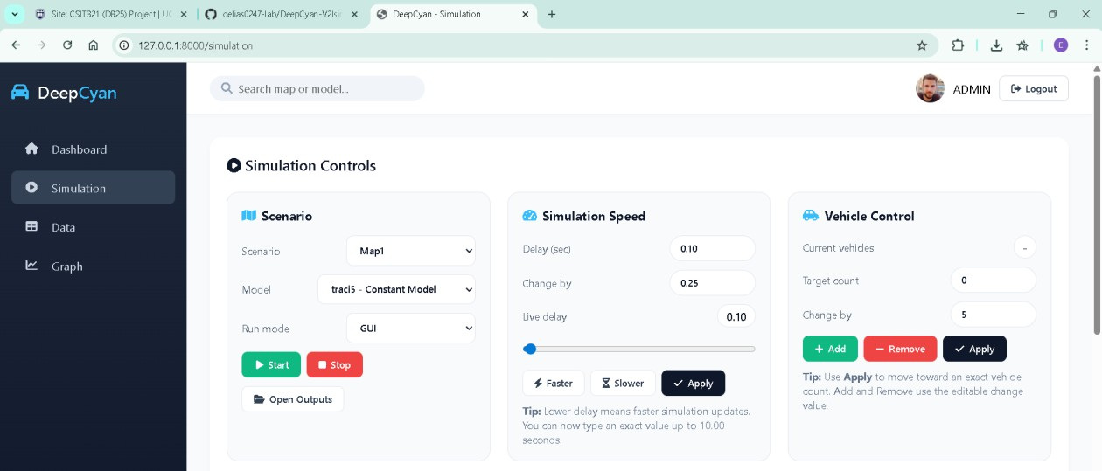
Simulation page

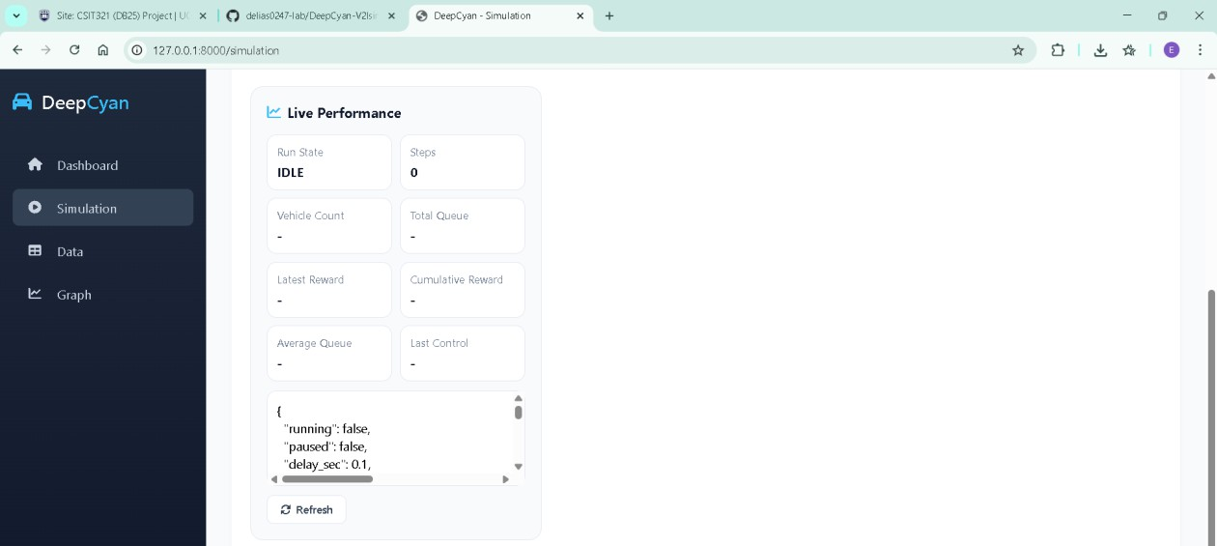
Live performance

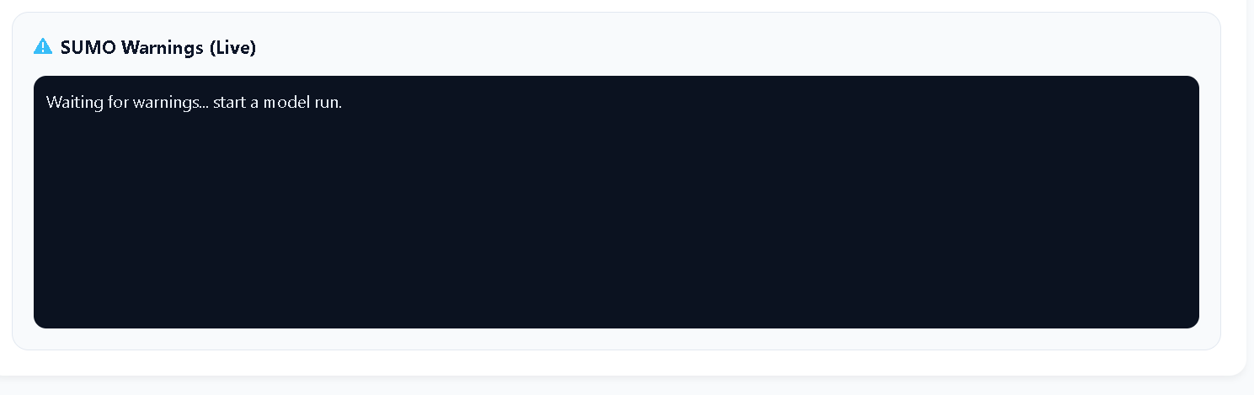
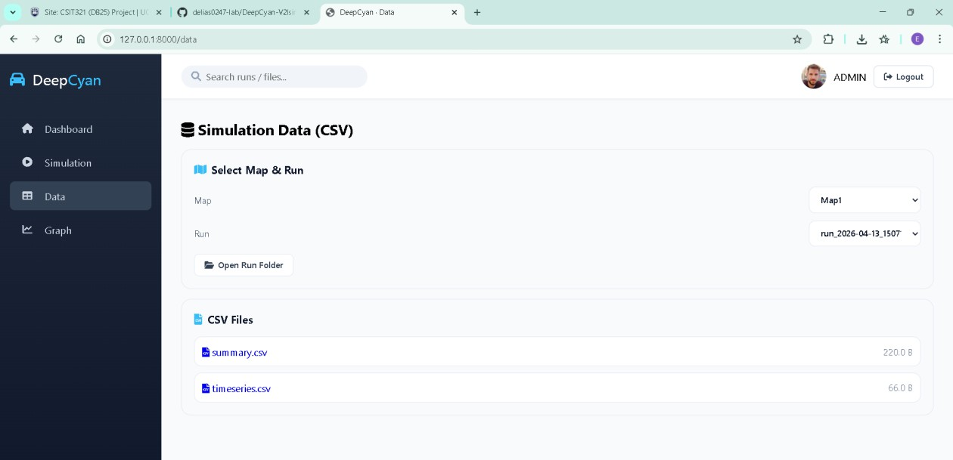
Data extraction

Graph and results comparisons

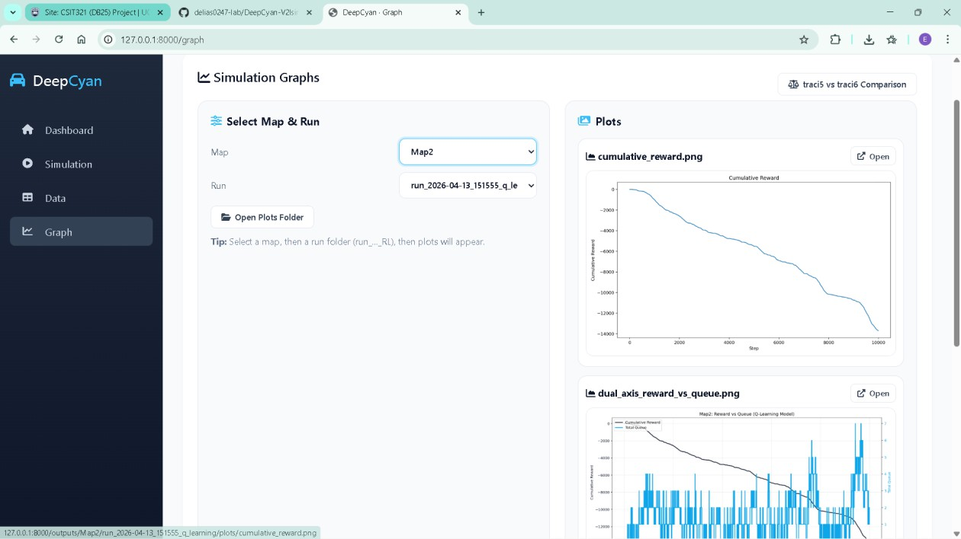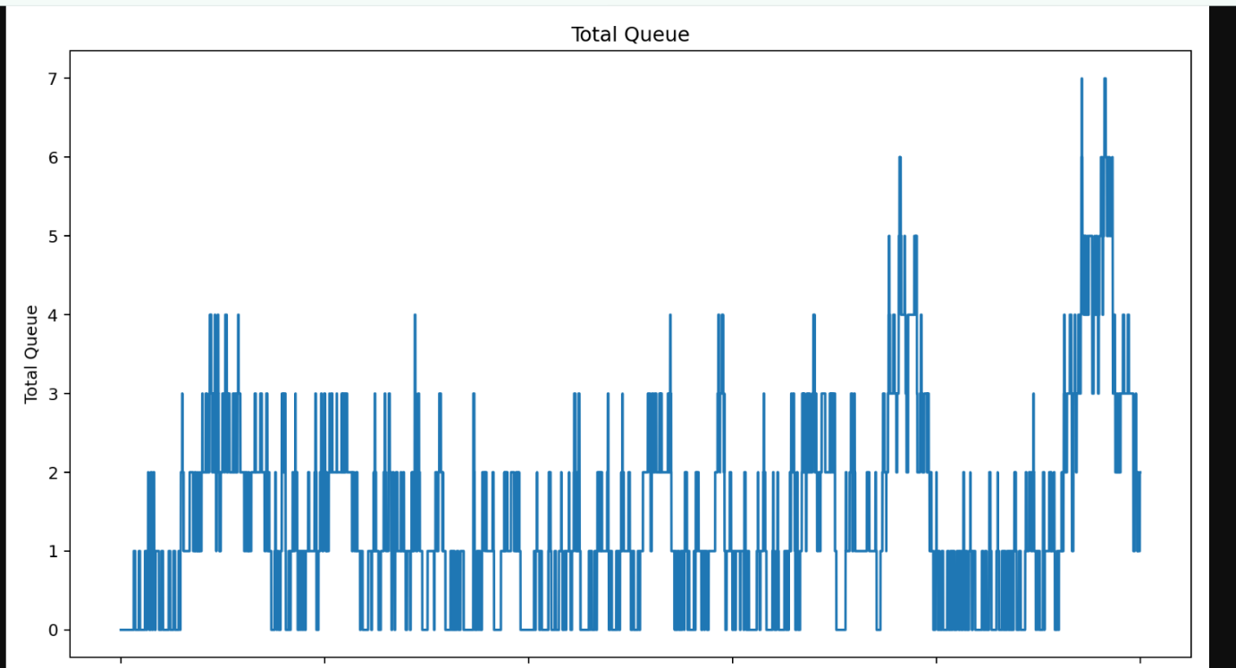

Model comparison

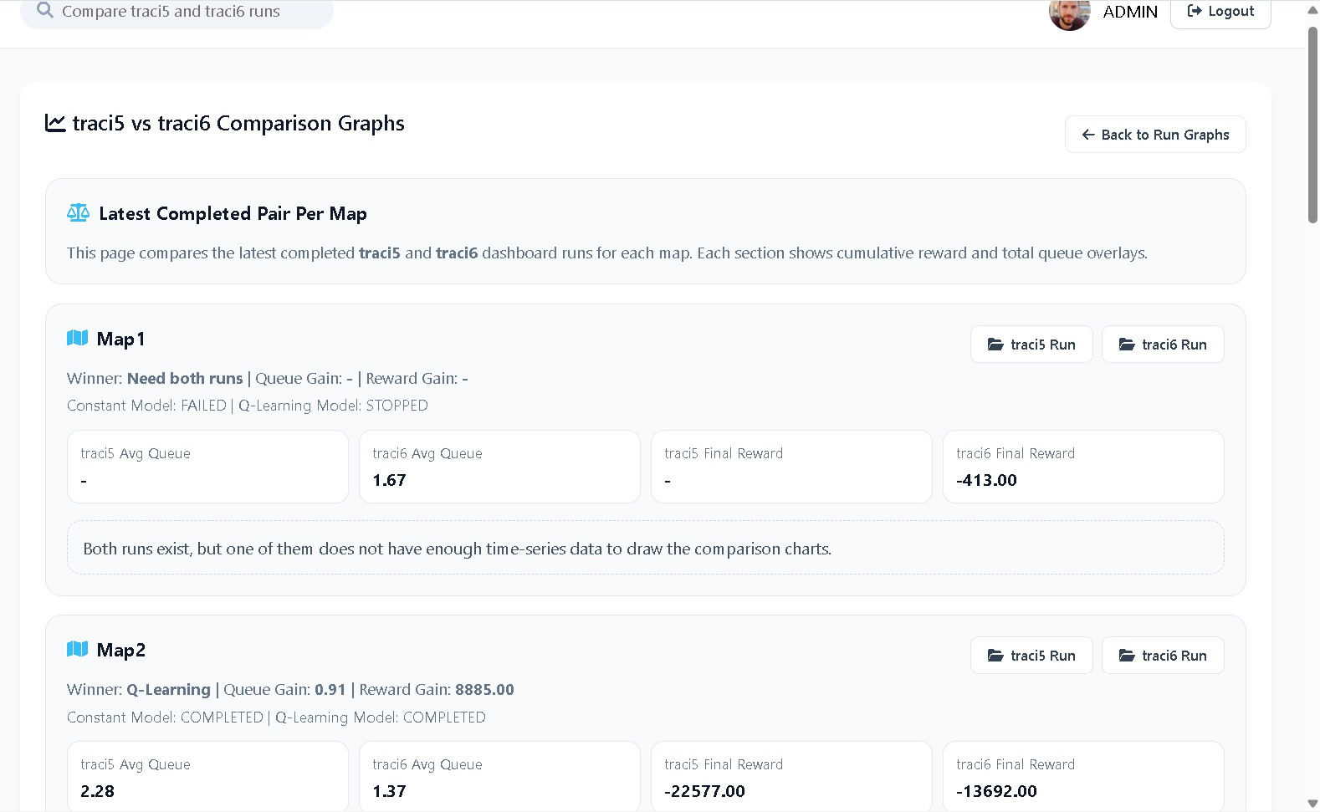
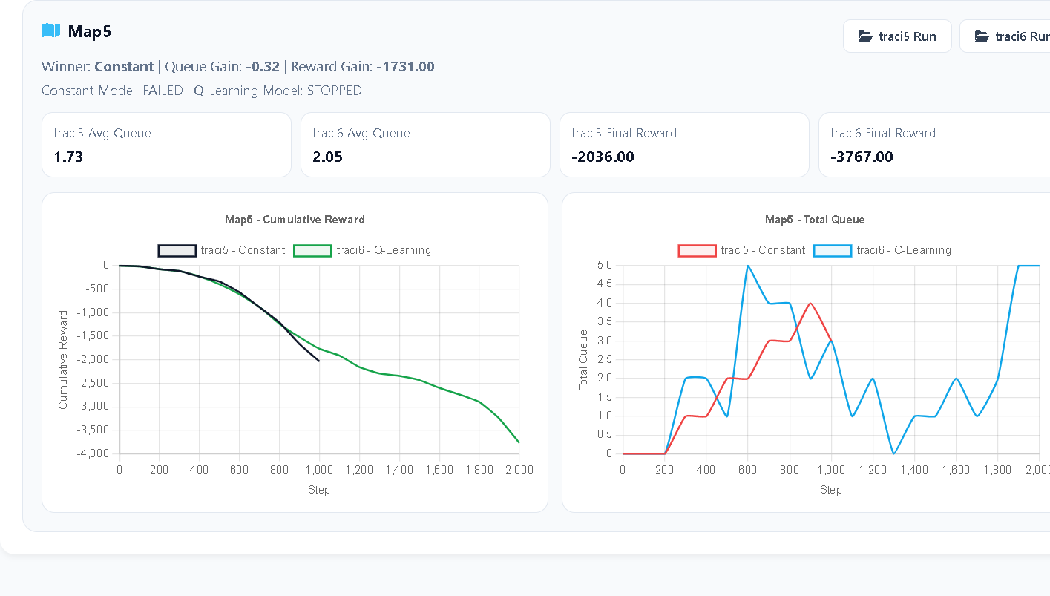




CHANGE REPORT

This section details the modifications made to the project scope, technical stack, and objectives since the initial Planning and Feasibility Analysis submitted in the first semester. These changes were necessitated by integration complexities and a shift toward a more robust Reinforcement Learning (RL) implementation.

Technical Stack Refinement
- Network Simulation: The original plan to use ns-3 for network-layer simulation was replaced with a focused TraCI and FastAPI integration.
- Rationale: While ns-3 provides high-fidelity packet-level simulation, its integration with SUMO and real-time Python ML models introduced significant synchronization latency that exceeded the target demo requirements.
- Implementation Change: We pivoted to using the TraCI (Traffic Control Interface) as the primary bridge, which allowed for lower-latency communication between the SUMO mobility environment and the AI controllers.

Shift in Project Scope (V2X to V2I)
- Original Scope: The first-semester proposal focused on Vehicle-to-Everything (V2X), including V2V (Vehicle-to-Vehicle) and V2P (Vehicle-to-Pedestrian) communication.
- Final Scope: The final project is specialized as V2I Sim, focusing on Vehicle-to-Infrastructure interactions.
- Key Focus: The emphasis shifted from generic message broadcasting to Intelligent Traffic Signal Control using Reinforcement Learning to optimize junctions and reduce congestion.

AI Model Evolution
- Predictive vs. Reactive: Early designs aimed at simple "Pattern Prediction" and collision anticipations.
- Final Implementation: We implemented a more complex comparison between Q-Learning and Deep Q-Learning (DQN) models to actively control traffic light phases rather than just predicting outcome states.

Data Persistence Strategy
- Database vs. Files: The initial requirements listed a PostgreSQL database for all telemetry storage.
- Final Adjustment: For the final demo, the system was optimized to use CSV and JSON time-series files to store simulation outputs.
- Rationale: This reduced the computational overhead on the single-machine containerized deployment, ensuring the simulation maintains the required 10 frames per second for visual monitoring.

Whilst the above reports are all updated to fit our current project, below we have added our initially submitted reports for your reference.


1ST
SEM -


PLANNING & FEASIBILITY ANALYSIS

Background Info about topic
The global automotive industry is transitioning towards intelligent and connected transportation systems. In order to increase safety, efficiency, and mobility, the global automotive industry is moving toward intelligent and linked transportation systems, in which automobiles now are more than ever required to interact with road infrastructure and with each other. Due to the ability that we currently have and the technological power that the world possesses and allows such industries to grow. Based decisions that are backed by self-learning machines now have the capabilities to make those split- second decisions that a human is unable to anticipate.
Smart city development relies heavily on Vehicle-to-Everything (V2X) communication, which includes Vehicle-to-Vehicle (V2V), Vehicle-to-Infrastructure (V2I), and Vehicle-to-Network (V2N) and Vehicle-to-Pedestrian(V2P). Only all these interactions together make up a complete Vehicle-to- Everything (V2X) communication, by leveraging this interaction we then have the capability to pursue and implement it to make our environment more harmonious.
However, building and testing these systems in the real world is expensive and complex. That’s why simulation plays a very important role. Simulation environments allow researchers and developers to model real-life traffic situations safely and test how connected vehicles and infrastructure would respond in those scenarios.
This project focuses on developing an AI-enhanced V2X communication simulation platform that demonstrates how AI and modern communication technologies can coordinate with each other and with their surroundings. The simulation will explore situations such as traffic coordination, collision avoidance, and real-time data exchange and explore how AI-driven decision-making can make future transportation systems safer and more efficient.

Project Description and Objectives What is our project?
An intelligent simulation that showcases the Vehicle to Everything V2X interaction and a scenario where it displays how smart vehicles navigate through an incident that could happen on the road. And Integration with available software that are helpful in building such networks, simulators and analysis models.
Our project makes use of software tools such as (SUMO, NS-3, and Python ML models) to simulate AI-based V2X communication in order to predict and avoid traffic congestion and accidents.
Objective
- Build a virtual vehicle communication testing environment.
- Utilizing AI to predict traffic congestion and identify any possible accidents.
- Prove how smart V2X communication can decrease delays and increase safety.
- Create a simulated platform and a network flow of vehicles.
- Analyse and use Machine learning algorithms for collision risks and traffic anticipations.
- Examine how in an urban setting, an Intelligent communication lowers traffic and show how accidents are managed.
Main Problem and How we Address them

- How we could solve High congestion roads
Increased vehicle density in urban areas causes delays, traffic bottlenecks, and fuel waste. Our Machine learning module forecasts congestion hotspots using predictive modelling after analysing real-time mobility patterns. The algorithm then suggests adaptive signal timings or optimal routes to reduce bottlenecks and increase the effectiveness of traffic flow.

- Navigation through collision
Drivers' inability to promptly perceive the actions of other vehicles, particularly at crossings or blind areas, is a major contributing factor in many urban incidents. In order to forecast accident risks and initiate early alerts, the AI layer continually assesses the speeds and trajectories of vehicles, enabling preventative safety measures.
- Lack of affordable real-world V2X testing infrastructure
Real-world V2X system deployment necessitates regulated testbeds and specialized hardware (roadside units, sensors, and on-board devices), both of which are expensive and logistically demanding. Our approach creates a realistic, scalable, and cost-free virtual testing environment that mimics real-world circumstances without physical deployments by utilizing open-source simulation platforms.

Project Scope
Competitor Solutions and their Limitations
- Simulation of Urban Mobility (SUMO): is an open-source, microscopic, and multi-modal traffic simulation platform. It enables researchers and engineers to model and analyse how individual vehicles, each with its own route and behaviour, move through complex road networks. SUMO supports simulations that incorporate various modes of transport including cars, buses, and pedestrians and can handle large-scale urban environments. By default, SUMO simulations are deterministic, but randomness can be introduced to reflect real-world variability. The software package includes a suite of tools for importing, generating, and preparing road networks and traffic demand data, making it highly versatile for studying traffic flow, congestion management, and mobility planning.
Limitation: Cannot simulate communication protocols by itself.
- Vehicles in Network Simulation (Veins): is an open-source simulation framework designed to model and analyse communication between vehicles (V2V) and between vehicles and infrastructure (V2I) collectively known as Vehicle-to-Everything (V2X) communication. It integrates two powerful simulation tools: OMNeT++ for network communication simulation and SUMO (Simulation of Urban MObility) for realistic vehicle mobility simulation. The two systems are synchronized in real time using the TraCI (Traffic Control Interface) protocol, which allows vehicles in SUMO to dynamically communicate with network nodes in OMNeT++.

Limitations: Lacks built-in AI predictive modules

- Network MATSim (Multi-Agent Transport Simulation MATSim: is a simulation of vehicle and commuter traffic based on real traffic demand. It is especially useful for presenting travel behaviours and planning transportation. However, it solely focuses on movement and routing, it does not support communication between vehicles or related infrastructure.

- I TETRIS (Integrated Traffic and Communication Simulation) : iTETRIS aims to bring together traffic and communication simulations to understand cooperative mobility systems. While it provides a valuable research framework, it is challenging to set up and has limited flexibility for incorporating or testing modern AI or machine learning models.

- CARLA (Car Learning to Act) : CARLA is a detailed 3D simulation environment designed for testing self-driving vehicles. It accurately simulates cameras, sensors, and vehicle patterns, making it suitable for research related to perception and control. Nonetheless, it does not support communication simulation among vehicles or networks, which is necessary for our project.
Target Niche
This platform primarily serves researchers, students, and developers focused on smart mobility,

transportation, and connected vehicle technologies. It proves especially valuable for urban planners
who want to assess foreseeable traffic scenarios, such as minimizing traffic or coordinating emergency responses, without the requirement for actual physical facilities or expensive equipment.
Pre-Requisites
  - Knowledge of Python programming, network simulation, and AI model design and C++ programming,
  - Basic understanding of ns-3 network module setup and communication standards.
  - knowledge on how to set up map files or pathways and experience with traffic simulation software.
Limitations
  - Simulation accuracy depends on map fidelity and model assumptions.
  - Real-time scalability limited by system hardware (CPU load during high-density traffic).
  - AI models trained on simulated data may not generalize directly to real-world environments.
  - No real IoT or vehicular sensor integration tested in the real world.
  - Scaling due to time computing consumption of a high level simulation How We Do It
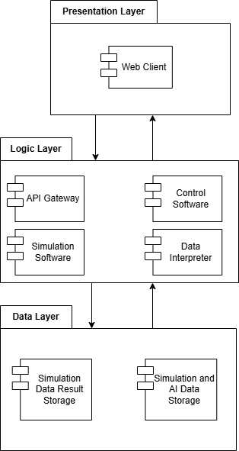
High level System Architecture

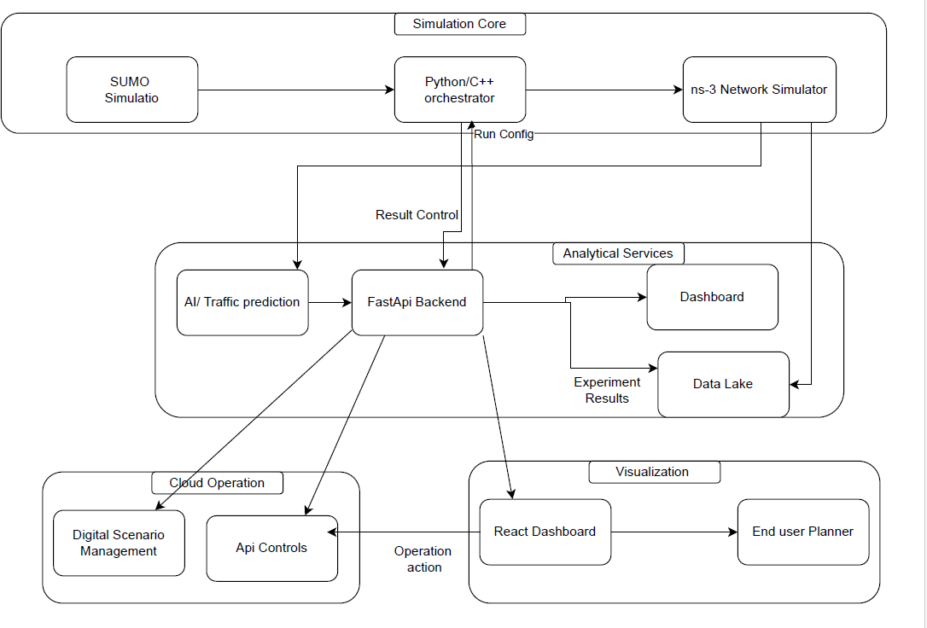
High Level System Operations

- Data Configuration/Input:
  - The user interacts with the Web Client and defines the parameters/variables for the simulation.
  - Configuration data (map, traffic density, etc) sent to Simulation and AI Data Storage.

- Initialization:
  - The Web Client begins a new simulation via sending a request through the API Gateway to the Control Software
  - Control Software accesses the Simulation and AI Data Storage to retrieve the pre-defined vehicles, routes, map and the AI Model.
  - Configures the Simulation Software based on input data.
  - AI Model data loaded into Data Interpreter.

- Simulation Running:
  - Control Software commands SUMO to engage traffic simulation along defined routes and traffic patterns.
  - Control Software passes data from SUMO into NS-3.
  - NS-3 simulates V2X communication between different vehicles and infrastructure.
  - Control Software passes data into Data Interpreter.
  - Data Interpreter:
  - Identifies vehicles on crash-collision course and outputs probability of collision and time-to- impact.
  - Analyses traffic-flow patterns and outputs probability of congestion before they occur.
  - Control Software takes preventative measures based on Data Interpreter.
  - Informs SUMO simulation to force specific cars to brake.
  - Informs NS-3 to issue warning messages to all nearby cars.
  - Adjusts routes and traffic infrastructure to adjust to reduce congestion.
  - Control Software stores all information collected into Simulation Data Result Storage.
- Data Display:

  - Web Client requests simulation information through API Gateway.
  - API Gateway retrieves information from Simulation Data Result Storage.
  - Data sent to Web Client.
  - User can see:
  - Animated movement of vehicles on dashboard.
  - Traffic-flow visualization.
  - Congestion and collision alert messages.
  - Data displaying performance of simulation.

Software and Hardware Requirements Software Requirements
Tools And Platforms
  - Simulation Tools: SUMO, ns-3
  - Programming & Integration: Python 3.10+, TraCI API
  - AI/ML Libraries: TensorFlow / PyTorch, Scikit-Learn, Pandas, NumPy, Random forest
  - Visualization: React.js, Grafana, FastAPI, Matplotlib
  - Version Control: GitHub
  - Containerization: Docker Compose Hardware Requirements
System Setup Hardware
  - Minimum: 8-core CPU, 16 GB RAM, 20 GB free disk space
  - Recommended: 12-core CPU, 32 GB RAM for high-density scenarios
  - No specialized IoT or physical devices required Specialized Hardware and Software’s
Approach 1:
  - A single Virtual Machine (VM) Faster to ship, good for demos, and apply 1 or 2 scenarios concurrently
Hardware : Development and show a Small demo
  - 8 core CPU, 16 GB Ram Memory, 50 GB SSD Storage Software:
  - Operating System Ubuntu 22.04
  - Runtime Docker Engine and Docker Compose
  - Networking: Nginx
  - Core Container
    - SUMO with netedit tools: for custom integration
    - Orchestrator: Python, TraCl glue, Batch Runner)
    - FastAPI: Backend Api
    - React UI : Dashboard
  - Control panel: managed through Google Kubernetes Engine(GKE), Amazon Elastic Kubernetes Service(EKS), and Azure Kubernetes Services (AKS)
  - Work Node Pool: 4 nodes each 8 VCPU, 16 GB Memory, 100 GB SSD

Specialized Hardware
In a real-world V2X deployment, specific hardware is mandatory. The project cleverly uses software simulations to replicate the functionality of this expensive hardware, making the project feasible and cost-effective.
Real-World Hardware | Software Simulation Equivalent in Your Project | Function

On-Board Units (OBUs) | Software agents representing each vehicle in the simulation (e.g., in SUMO, NS-3). | The "intelligence" in each car. In your sim, this is the code that receives messages (e.g., about an accident ahead), processes them using your ML model, and decides on a new route or speed.
Roadside Units (RSUs) | A dedicated simulation node or a software controller. | Acts as a local communication hub. In your incident scenario, a virtual RSU would be the entity broadcasting the "Accident Ahead" message to all vehicles in a certain radius.
GNSS/GPS Receivers | Built-in coordinate and positioning systems of the simulator (SUMO's network). | Provides precise vehicle location. This data is fed into your ML algorithm to track trajectories and predict collision risks.
Dedicated Short-Range Communication (DSRC)  / Cellular-V2X (C-V2X) Modules | Network communication modules in a network simulator (e.g., NS-3, OMNeT++). | The virtual "radio" that allows vehicles (OBUs) and infrastructure (RSUs) to exchange messages. It simulates packet loss, latency, and range.
Sensors (LiDAR, Radar, Cameras) | Simulated sensor data generated from the virtual environment. | Provides the raw data (e.g., relative distance to other vehicles, speed of lead vehicle) that your ML model uses for real-time risk assessment.
This integration is the core of "affordable virtual testing environment." Challenges
  - Synchronizing large-scale mobility and network events in real time.
  - Ensuring low latency between SUMO and ns-3 simulators.
  - Designing efficient Machine learning models that can run during simulation without

bottlenecks.
  - Data storage and visualization performance for large datasets.
- Model Accuracy vs. Computational Complexity:
  - Challenge: Creating a highly realistic simulation (with thousands of vehicles, complex driver behaviours, and precise network conditions) requires immense computational power. There is a constant trade-off between the accuracy of the simulation and the time it takes to run it.
  - The Project’s Hurdle: The ML algorithm for collision anticipation is only as good as the data it’s trained on. If the simulated traffic patterns or driver behaviours are not realistic, the model’s predictions will not be reliable for real-world application.
- Integration Complexity:
  - Challenge: The project relies on the seamless integration of multiple software platforms (e.g., SUMO for traffic, NS-3 for networking, and a Python environment for the ML model). Ensuring they communicate in real-time, share data correctly (e.g., vehicle position from SUMO to NS-3, and delay from NS-3 back to SUMO), and remain synchronized is a significant software engineering challenge.
- Standardization of V2X Messages:
  - Challenge: The real world uses standardized message sets like SAE J2735 (Basic Safety Messages - BSM, Signal Phase and Timing - SPaT). Your simulation must implement these message standards to be credible. Designing and correctly interpreting these virtual messages is a non-trivial task.
- Validating the "Intelligence":
  - Challenge: The core objective is to show that "intelligent communication lowers traffic and manages accidents." Proving this quantitatively is a challenge. You need to define clear metrics (e.g., average delay reduced by X%, number of stops decreased by Y%) and run controlled simulations with and without the V2X system to validate the benefits.

Future Improvements
- Digital Twin Integration:
  - Improvement: Move from a generic simulated city to a "Digital Twin" of a real-world urban area (e.g., using OpenStreetMap data for a specific city like downtown Boston). This would dramatically increase the project's relevance and allow for direct comparison of your model's recommendations with real-world traffic data.
- Incorporating Vulnerable Road Users (VRUs):
  - Improvement: Expand the simulation to include pedestrians and cyclists. Implement V2X communication to protect these VRUs, for example, by having their smartphones broadcast location data to nearby vehicles, allowing your ML model to predict and alert for potential collisions at intersections.
- Advanced AI/ML Models:
  - Improvement: Evolve from predictive modelling of congestion to using Deep Reinforcement Learning (DRL). In a DRL model, the AI agent (e.g., a traffic light controller) learns the optimal signal timing policy through trial and error, potentially outperforming pre-defined adaptive algorithms.
  - Improvement: Implement Federated Learning on the simulated vehicles. This would allow vehicles to collaboratively improve the shared risk-prediction model without sharing their raw, private data, addressing a key privacy concern in real-world V2X.
- Edge Computing Scenario:
  - Improvement: Introduce a simulated "Edge Server" into the network architecture. This would allow you to test scenarios where highly computationally intensive tasks (like processing data from multiple vehicles to predict a complex multi-car collision) are offloaded from the vehicles to a nearby edge server, reducing latency for critical decisions.
- Cybersecurity and Resilience Testing:
  - Improvement: Use your simulation as a testbed for V2X security. Introduce malicious actors that send spoofed messages (e.g., a false "Deceleration Emergency" message) and

develop/validate defines mechanisms that your AI can use to detect and mitigate these attacks.
This is a critical real-world concern.

TimeLine
To ensure systematic progress and balanced workload distribution, the project timeline details each key activity—from early simulation setup and model design to final testing and presentation—guided by Agile planning principles.
Gantt Chart
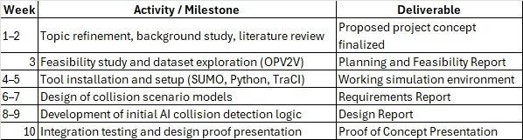
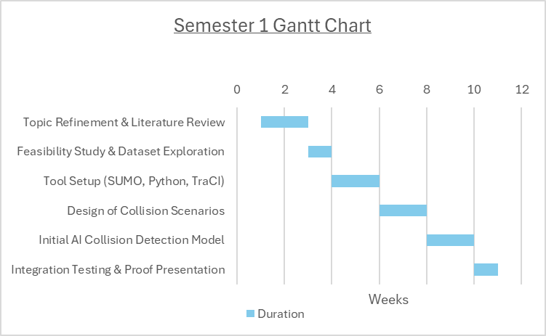
Semester 1 Work Breakdown
Semester 2 Work Breakdown
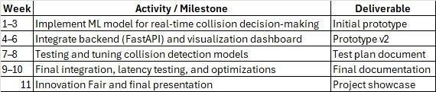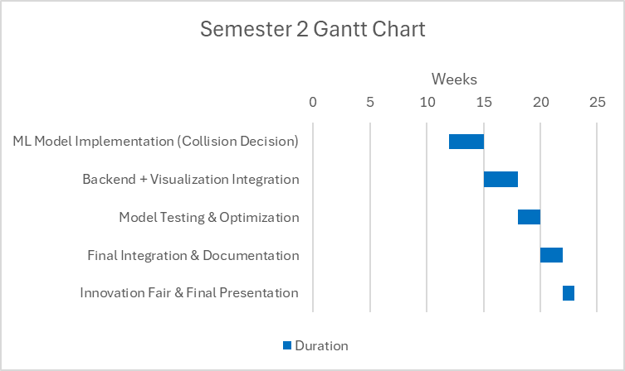
Gantt chart

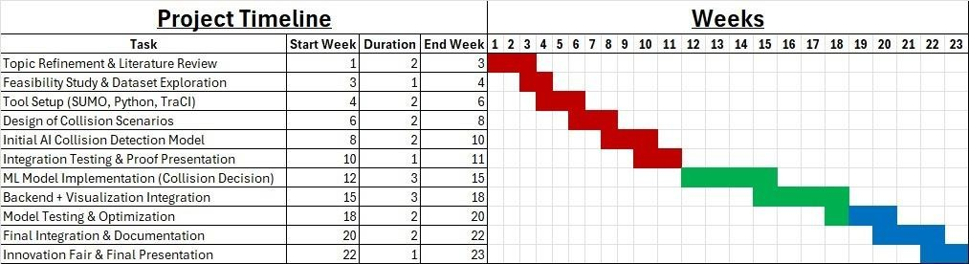
Project Management Tools To Be Used
Agile Programming and Prototyping Approach
To ensure flexibility, efficiency, and collaboration throughout the project’s lifecycle, the development team will ensure to adopt an Agile Software Development methodology combined with iterative prototyping.
Agile Framework
The project will follow a Scrum-style workflow operating in 2-week sprints. Each sprint will include:
  - Sprint Planning: Define sprint goals, deliverables, and responsibilities.
  - Daily/Weekly Stand-ups: Monitor progress, identify blockers, and maintain transparency.
  - Sprint Review: Demonstrate progress to supervisors and gather feedback.
  - Retrospective: Reflect on sprint performance and identify areas for improvement.
This cyclical process promotes incremental progress, early feedback, and adative planning, enabling the team to respond effectively to new technical insights and challenges.
Prototyping Strategy
Functional prototypes will be developed early (within the first three weeks) to:
  - Validate simulation feasibility,
  - Establish the communication pipeline, and
  - Test integration between SUMO, Python (TraCI), and AI modules. Subsequent prototypes will iteratively integrate:
  - AI analytics modules for collision detection,
  - FastAPI backend for data handling, and
  - Visualization UI for interactive representation.
Each prototype iteration will undergo team and instructor reviews to ensure alignment with project objectives and key evaluation metrics (e.g., latency, throughput, collision detection accuracy).
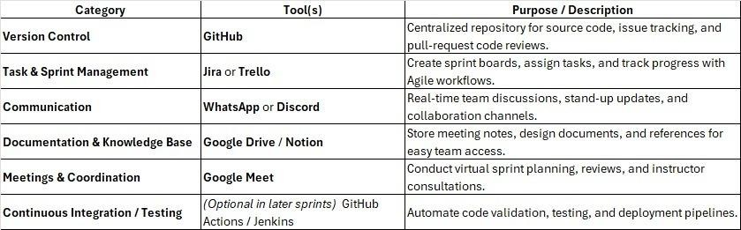
Tools & Uses

Team Work Distribution
Team Member | Contributions
Ahmed Hossam Abdelmagyd | Specialized Hardware, Challenges, Future Improvements, Special Hardware
Ahmed Imran | Competitor Solution and limitation, Target Niche, Pre-requisites, Limitation

Anam Asim Siddiqui | What is our Project, Project Scope
Elias Dawit Seyoum | First Document Draft, Software and Hardware requirements, Tools and Platform, Special Hardware,
Elisha Danielle Johnson | Project Management tools used, Gantt Chart
Maryam Muhammad Yaqoob | Background Info Project Objective, How to address the Problem
Mvansh Kanojia | High level Systems Architecture, High level system operation

Technical Work Distribution
Team Member | Student Numbers | Contributions
Ahmed Hossam Abdelmagyd | 8205255 | Build the simulation Scenario
Ahmed Imran | 7936277 | Build the simulation Scenario
Anam Asim Siddiqui | 7788794 | Develop a simulation api Dashboard platform
Elias Dawit Seyoum | 7580836 | Integration of simulation and
Elisha Danielle Johnson | 7675331 | Development of the Pattern prediction ML
Maryam Muhammad Yaqoob | 8368557 | Develop a simulation api Dashboard platform
Mvansh Kanojia | 8303873 | Build the Vehicle Network Platform



1ST
SEM -


DESIGN DOCUMENT

1 INTRODUCTION
Purpose
The purpose of this Software Design Document (SDD) is to describe the architecture, components, data structures, and design decisions of the V2V Simulation Platform, a system developed to model and visualize vehicle-to-vehicle communication in an urban driving environment. This document serves as a technical guide for developers, testers, instructors, and stakeholders involved in the implementation and evaluation of the system.
The SDD provides a detailed description of how the system is structured, how its components interact, and how the simulation supports V2V communication, collision detection, and cooperative driving behaviour. It ensures that the software can be implemented consistently, maintained efficiently, and extended in the future if additional V2X functionalities are added.
This document is intended for:
  - Software developers responsible for implementation
  - Testers validating functional correctness and safety logic
  - Supervisors and academic evaluators reviewing design quality
  - Future project contributors who may expand the system to full V2X capability

Scope of the Project
The V2V Simulation Platform focuses exclusively on modelling vehicle-to-vehicle communication within an urban driving environment. The goal is to demonstrate how vehicles exchange critical safety information and how this communication affects driving behavior, collision avoidance, and overall road safety.
In this version of the project, vehicles broadcast and receive key data elements such as speed, location, direction, brake status, hazard alerts, and other basic state information. By sharing these details in real time, vehicles can anticipate potential risks and adjust their behavior accordingly. The simulation showcases how V2V communication reduces the likelihood of accidents and supports cooperative driving.
The scope includes the simulation of two to several vehicles interacting in a simplified urban road layout. The project examines two to three types of collision scenarios commonly observed in such environments for example, rear-end collisions, side collisions, or merging conflicts. Collision detection logic is integrated to identify risk conditions, trigger alerts, and demonstrate how vehicles respond when communication predicts danger.
The project deliverables include a working prototype, communication logic, collision-detection engine, a simple but functional user interface, event logging, and visual animations that illustrate real- time exchanges between vehicles. This ensures the system provides both analytical insights and an intuitive visual representation of V2V safety behavior.
To maintain clear focus, the project scope excludes pedestrians, traffic lights, road infrastructure units, and any V2I, V2P, or V2N communication. Only direct vehicle-to-vehicle interactions are considered. This narrowed scope allows for a deeper examination of V2V cooperative safety, enabling the team to analyse communication-driven driving responses and the mechanics of collision prediction and avoidance in an urban environment.
- SYSTEM OVERVIEW

The V2V Simulation Platform is an interactive software system designed to demonstrate and analyse

direct vehicle-to-vehicle communication within a simplified urban road environment. It models how
multiple vehicles move, share safety-critical information, and react to potential collision threats using cooperative communication logic.
Each simulated vehicle continuously broadcasts its state such as speed, position, direction, brake status, and hazard alerts via a V2V communication module such could be Network simulator (Ns-3). These messages enable nearby vehicles to build awareness of their surroundings and modify their driving behaviour when necessary. The collision detection module evaluates the positions and speeds of vehicles to identify possible rear-end, side, or merging collision risks. When a risk is predicted, vehicles respond by braking, slowing down, or activating hazard indicators.
The system’s architecture is composed of modular subsystems: the simulation engine that drives the time steps, the vehicle model that represents each vehicle's dynamics, the V2V communication service that handles message exchange, the collision detection module that analyses risk, the event logger that records system events, and a graphical UI for real-time visualization.
This project focuses solely on V2V interactions, intentionally excluding traffic lights, pedestrians, roadside units, or network/cloud communication. The platform provides a simplified yet meaningful environment for studying cooperative safety behaviour and understanding how V2V data exchange influences driving performance and collision avoidance.

Finally, user interaction is facilitated through a simple simulation dashboard where the user can load predefined scenarios and control key factors such as vehicle speed, starting positions, and movement behaviour. The dashboard allows the user to observe, in real time, how V2V data is exchanged between vehicles and how this information influences vehicle decision-making during potential collision scenarios. All communication events, warnings, and collision predictions are visually displayed on the main dashboard, along with detailed logs that track system activity. Users can adjust simulation parameters to generate different outcomes, analyse risk levels, and better understand the impact of V2V communication on cooperative driving and collision avoidance.
- SYSTEM ARCHITECTURE
  - Architectural Design
The architecture of the V2V Simulation Platform is designed using a modular structure that separates the system into logical subsystems. Each subsystem handles a specific aspect of the simulation, allowing the system to be easily maintained, extended, and tested. The architecture follows a lightweight, layered model where the Simulation Engine, Communication Module, and Collision Detection Module form the core logic, while the User Interface layer provides visual interaction and feedback.
At the highest level, the system consists of the following major subsystems:
- User Interface (UI) Subsystem Role:
Provides a graphical interface for rendering the moving vehicles, visualizing communication events, and displaying warnings or logs.
Responsibilities:
  - Canvas rendering of vehicles and their positions
  - Displaying alerts (e.g., potential collision warnings)
  - Showing event logs and status messages
  - Capturing basic user interactions (start/stop simulation)

- Simulation Engine Role:
Manages the lifecycle of the simulation and updates vehicle states at each time step. Responsibilities:
  - Vehicle movement and kinematics (speed, direction, braking)
  - Updating positions at each simulation tick
  - Feeding updated states into the communication module

  - Managing the timing and execution of simulation loops

- Vehicle Model Subsystem Role:
Represents each vehicle as an independent entity with attributes and behaviours. Responsibilities:
  - Holding vehicle state (speed, location, direction, brake status)
  - Updating its behaviour based on messages or collision risk
  - Generating outbound communication packets
  - Responding to alerts (braking, slowing down)

- V2V Communication Module Role:
Handles the exchange of information between vehicles. Responsibilities:
  - Broadcasting vehicle state information
  - Receiving messages from other vehicles
  - Filtering messages (e.g., nearest vehicles only
  - Sharing hazard alerts or emergency braking signals with others
  - Passing received data to the Collision Detection Module

- Collision Detection Module Role:
Analyzes real-time vehicle states and identifies potential collision risks. Responsibilities:
  - Computing distance and relative speed between vehicles
  - Detecting rear-end and side-collision scenarios
  - Triggering early alerts
  - Sending collision warnings to vehicle entities
  - Logging collision events

- Event Logger Role:
Records safety messages, warnings, and communication events. Responsibilities:
  - Storing messages exchanged between vehicles
  - Logging collision warnings
  - Displaying logs through the UI subsystem

Subsystem Collaboration
The subsystems collaborate in the following sequence:
- Simulation Engine updates each vehicle’s movement.
- The Vehicle Model sends its updated state to the V2V Communication Module.
- The Communication Module broadcasts the state to nearby vehicles.
- The Collision Detection Module evaluates received data for possible collision scenarios.
- If danger is detected:

  - A warning is sent back to the affected vehicle
  - Vehicles adjust driving behaviour (slow down or brake)
  - A message is logged by the Event Logger
- The User Interface renders all updates visually.

This modular flow ensures clear separation of responsibilities while supporting real-time V2V safety simulation.
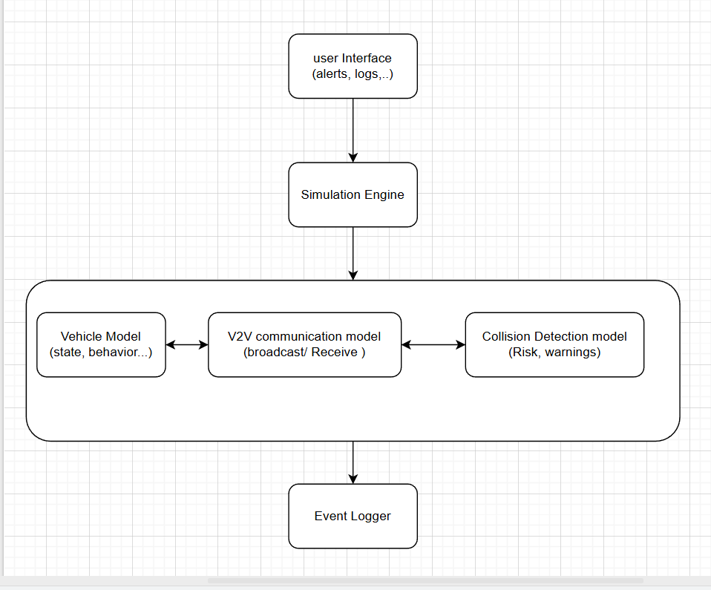

  - Decomposition Description
This section provides an object-oriented decomposition of the V2V Simulation Platform based on the high-level architecture in Section 3.1. The system is organized into subsystems, each realized as a set of collaborating classes.

    - Subsystem Model
At a high level, the system is decomposed into the following OO subsystems:
      - User Interface (UI) Subsystem
      - Simulation Engine Subsystem
      - Vehicle Model Subsystem
      - V2V Communication Subsystem
      - Collision Detection Subsystem
      - Event Logging Subsystem

These subsystems collaborate to simulate vehicle movement, V2V communication, collision detection, and visualization.

    - Main Classes by Subsystem
- User Interface Subsystem
  - Main Window
    - Responsible for application startup, initialization of the simulation, and linking UI components with core logic.
  - Simulation View
    - Renders vehicles on the screen (e.g., canvas), showing their positions, directions, and states (e.g., braking).
  - Control Panel
    - Provides basic controls such as Start, Pause, Reset simulation.
  - Log View
    - Displays event logs, including warnings, messages, and collision alerts. Key relationships:
  - Main Window aggregates Simulation View, Control Panel, and Log View.
  - Simulation View reads vehicle states from the Simulation Controller (Simulation Engine).

- Simulation Engine Subsystem
  - Simulation Controller
    - Central orchestrator of the simulation.
    - Advances the simulation time step-by-step.
    - Calls updates on Vehicle Manager, V2VCommService, Collision Detector, and Event Logger.
  - Time Step Scheduler (optional/helper)
    - Manages timing intervals between simulation updates (e.g., using a fixed tick rate). Key relationships:
  - Simulation Controller aggregates:
    - Vehicle Manager
    - V2VCommService
    - Collision Detector
    - Event Logger
  - Simulation Controller is observed/triggered by the UI (start/stop).

- Vehicle Model Subsystem
  - Vehicle
    - Represents an individual vehicle in the simulation.
    - Attributes: id, position, velocity, direction, hazard Status.
  - Vehicle Manager
    - Maintains a collection of Vehicle instances.

Key relationships:
  - Vehicle Manager aggregates many Vehicle objects.
  - Simulation Controller uses Vehicle Manager to update and retrieve vehicle states.
Possible generalization (future):
Vehicle could be extended into subtypes like Car, Bus, Emergency Vehicle, but for this scope we keep a single Vehicle class.

- V2V Communication Subsystem
  - V2VMessage
    - Represents a message sent between vehicles.

    - Fields may include: sender Id, position, speed, direction, hazard Alert, timestamp.
  - V2VCommService
    - Handles broadcasting and receiving messages.
    - Methods:
      - Broadcast Status(vehicle)
      - receive Messages()
      - get Messages For Vehicle(vehicle)
    - Responsible for logical message routing (e.g., only vehicles in range or in the same area).

Key relationships:
  - Vehicle uses V2VCommService to send V2VMessage objects.
  - Collision Detector reads V2V data (directly or via the service) to analyse risks.

- Collision Detection Subsystem
  - Collision Detector
    - Core analysis component for collision risk.
    - Methods:
      - Check Collisions(vehicles)
      - Predict Collision(vehicleA, vehicleB)
    - Computes distances, relative speeds, and predicts possible collisions (e.g., rear-end, side collision).
  - Collision Event
    - Represents a detected or predicted collision event.
    - Fields: vehicleA Id, vehicleB Id, collision Type, risk Level, timestamp.

Key relationships:
  - Simulation Controller calls Collision Detector. Check Collisions() each time step.
  - On risk detection, Collision Detector may:
    - Notify Vehicle Manager/Vehicle objects (e.g., to brake)
    - Log Collision Event via Event Logger.
- Event Logging Subsystem
  - Event Logger
    - Central logging service for simulation events.
    - Methods: log Message(), logWarning(), logCollisionEvent(), getRecentEvents().
  - Log Entry
    - Represents a single log entry (text, type, timestamp, related vehicles). Key relationships:
  - Simulation Controller, Collision Detector, and V2VCommService all write to Event Logger.
  - Log View (in the UI) reads from Event Logger to display events.

  - Design Rationale
The chosen architecture is modular, object-oriented, and layered, designed to support clarity, extensibility, and educational value within the constraints of a capstone project.
    - Reasons for the Chosen Architecture
      - Separation of Concerns
        - Splitting the system into UI, Simulation Engine, Vehicle Model, Communication, Collision Detection, and Logging subsystems allows each part to be developed, tested,

and modified independently.
        - This separation reflects real-world V2X systems conceptually (vehicles, communication layers, safety logic, visualization).
      - Maintainability and Readability
        - Using clear classes such as Vehicle, V2VMessage, and CollisionDetector aligns with how students and developers naturally think about the domain.
        - Bugs can be localized to specific subsystems (e.g., collision logic vs. rendering).
    - Alternatives Considered
      - Full Client–Server or Microservices Architecture
        - Description: Separate backend (simulation and logic) and frontend (UI) into distinct services communicating over HTTP/WebSocket or use multiple microservices (e.g., one for simulation, one for logging, one for analytics).
        - Reason Not Chosen:
          - Adds deployment, networking, and orchestration complexity.
          - Overkill for a single-machine capstone prototype.
          - Would shift focus away from the core goal: understanding V2V behaviour and safety logic.

      - Integration with Heavyweight Simulation Frameworks (e.g., SUMO + ns-3)
        - Description: Use established mobility and network simulators and integrate them into the project.
        - Reason Not Chosen (for this version):
          - Steep learning curve and significant integration overhead.
          - Difficult to fully configure and control within the course timeframe.
          - The capstone currently focuses on a conceptual, simplified V2V scenario; full SUMO/ns-3 integration is better left as future work.

    - Key Trade-offs
- Simplicity vs. Realism
  - The architecture Favors a simpler, discrete-time simulation and abstract communication model rather than exact physical vehicle dynamics or real wireless channel models.
  - This trade-off allows clearer focus on V2V logic and collision scenarios.

- Performance vs. Modularity
  - The design introduces multiple classes and method calls, which is more modular but slightly less performant than a tightly optimized, low-level implementation.
  - Given the relatively small number of vehicles and academic context, modularity was prioritized.

- DATA DESIGN
  - Data Description
The information domain of the V2V Simulation Platform centres around a set of moving vehicles, their states, the messages they exchange, detected collision risks, and logged events. All core data is held in memory during a simulation run. For this version of the project, data is primarily stored in objects, collections (lists/arrays), and simple in-memory structures. The V2V simulator manages the data in differing stages: Input Data, Processing Data, Logging Data.

Vehicle State Data

Each vehicle represented by a vehicle object. It will consist of dynamic properties such as
- Position (x, y), Speed, Direction, Brake status, Hazard status, Unique vehicle ID V2V communication Data: communication between vehicles could contain data such as
- Sender vehicle ID, Current position and speed, Direction, Brake status, Hazard alert information, Timestamp

Description: Files created before simulation begins. Contains information that defines parameters and variables of the simulation.
Storage: XML files are used for map and vehicle traffic since SUMO requires that specific file type. JSON files can then be used for other parts of our simulation to be easily processed by a Python script. Usage: The simulator reads the file to build the virtual environment.

Processing Data
Description: Data that continually is changing while the simulation is being run.
Storage: This data would be stored in the RAM due to the constantly rapid change that the values would undergo due to the simulation and real-time calculations that would occur which would be far too slow without if it were stored on the hard disk.
Usage: The AI and simulator would need to use this data to calculate and process logical data such as calculating time-to-impact, collision risk, etc.

Logging/Output Data
Description: Record logs of what occurred during the simulation to be displayed and analysed. Storage: Data is sent to the dashboard via the API as well as being stored in as a JSON file with key events logged.
Usage: The dashboard can display real-time animation of the on-going simulation.

  - Data Dictionary Alphabetically
Table 1: Data Types for Config Data
Name | Data  Type | Description
AI_Model | .pt | File containing pre-trained AI model used for prediction.
Road_Info | .xml | SUMO file that contains road information and variables like lanes, speed limit, etc.
Scenario_Config | .json | File containing user-defined parameters and variables like vehicle amount, weather condition, etc.
Traffic_Info | .xml | SUMO file containing specified pathing and timer for vehicle spawning.

Table 2: Data Types for Runtime Data
Name | Attribute | Type | Description
Vehicle | Id | String | Unique identifier for each vehicle, can be used to link SUMO and NS3

 | Position | Tuple | Coordinate of the vehicle in the map
 | Speed | float | Current speed of the vehicle
BSM_Packet | payload | object | Basic Safety Message used for communication between vehicles
 | timestamp | float | Simulator time for when message was sent out
Connection_Quality | latency | float | Time delay of signal travelling between vehicles
 | packet_loss | boolean | To determine whether signal connection is too weak
AI_Output | collision_risk | float | Probability of collision occuring
 | stopping_probability | float | Probability of vehicle stopping due to traffic congestion

Table 3: Data Types for Output Data
Name | Attribute | Type | Description
System_log | event_log | string | Key moments where important events  occurred get recorded and can be viewed by the user
Sim_telemetry | risk_prediction | object | predictions made by the AI displayed on the dashboard
 | Vehicle_data | list | Real-time positions and data of vehicles used for visuals
 | V2v_networking | list | Visual representation of network communication  between vehicles displaying data exchange
- COMPONENT DESIGN
V2X is a simulation environment that we will use to design and demonstrate how Vechicle-To- Vehicle(V2V) communication can be established alongside with the implementation of basic AI prediction models with-in a single platform.

Our project only focuses on one aspect of V2X ecosystem which is the V2V interaction aspect. These
interactions between vehicles aim to exchange key information regarding the movement and positioning of the vehicles to improve safety and situational awareness at any given point in the journey.

Main Tools Used in System:
- Traffic Mobility Simulator (SUMO)
- Network Communication Simulator (NS-3)
- Ai prediction.
- Dashboard SUMO:
The system aims to use this simulator to generate real life alike scenarios of road environment and vehicle movement. SUMO will also help adjust movement perimeters such as speed, position and route establishment.

NS-3:
This part of the system acts as the communication layer of our system. It will be responsible
for the synchronizing of mobility data and to simulate real life like factors such as latency, packet loss, signal range/strength this helping the simulation derive better and more realistic results

Ai prediction model:
Using basic MLL, AI model will be trained for prediction statistics and probability calculations. Underlying risks of collisions, traffic stop probabilities, speed and distance between vehicles are some of the data that will be part of the output from this model. This is meant to show how machine learning can help in connected vehicle systems rather than a fully autonomous one.

Finally, the user interaction is enabled through a web dashboard where the user is allowed to load scenarios and control factors such as vehicle movement, speed and more.
The dashboard allows the user to observe, live time, what the V2V data exchange between vehicles looks like and how this data is then transferred to the system through NS2 and then processed using the MLL AI model to be displayed on the main dashboard. The user can view final predictions and logs on the main dashboard and make judgements of the results or adjust perimeters to generate different outcomes and potentially alter/reduce risk factors with-in the simulation.
- HUMAN INTERFACE DESIGN

  - Overview of User Interface
The user interface (UI) of the V2V Simulation Platform is designed to provide a clear, intuitive, and visual representation of real-time interactions between multiple vehicles. From the user’s perspective, the system acts as a simulation dashboard where vehicle positions, movements, communication events, and collision warnings are displayed dynamically.
Interface Objectives:
- It provides a clear and easy way to load and run the simulations.
- Observe the movement of vehicles along an urban road layout on the main canvas.
- View visual indicators such as braking signals, hazard alerts, or sudden slowdowns.
- It also allows the user to modify the parameters and see results instantly.
- Inspect communication events, such as broadcast messages exchanged between vehicles.
- Receive warnings and notifications when a collision risk is predicted or detected.
- Monitor detailed event logs showing V2V messages, collision warnings, timestamps, and related vehicle IDs.

The design ensures clarity and real-time responsiveness so users can understand how V2V communication supports driver assistance, collision avoidance, and cooperative driving behaviours.

Main User Interface Components:
- Navigation bar: The navigation bar provides quick access to all major sections of the system. It includes links to the Dashboard, Control Panel, Scenario Setup, Logs, and the Live Simulation View, enabling seamless navigation throughout the application.
- Scenario Setup: This section is used prior to running a simulation. The user can select the SUMO map file, define the number of vehicles, and configure essential simulation parameters. It also includes controls for Start, Stop, and Reset, ensuring the user can properly initialize and manage the simulation environment. Live Simulation View- It displays the information in real time of the vehicle locations from SUMO, V2V communications from NS-3, data for delay, packet loss and quality of the connection, and AI predictions.
- Live Simulation view: The live simulation screen presents real-time information from both SUMO and NS-3. It displays vehicle positions on the map, ongoing V2V communication packets, network metrics such as delay and packet loss, and AI-based risk predictions. This view allows users to observe the dynamic behaviour of the entire system as the simulation executes.
- Logs: The logs page records key simulation events, AI predictions, alerts, and safety responses. It provides a chronological breakdown of system activity, helping users analyse performance, identify issues, and understand the reasoning behind interventions or alerts.

Key Interface Components:
  - Control Buttons: Includes Start, Stop, Pause, and Export Logs for managing simulation flow and retrieving results.
  - Input Fields: Used for selecting scenario files, setting parameters, and configuring simulation options.
  - Real-Time Visual Animation: Shows vehicle movement, V2V communication links, and network activity as animated elements.
  - Alerts & Indicators: Color-coded warnings highlight weak communication, high-risk predictions, or potential collision scenarios.

User Interaction Flow:
- The user begins by selecting the desired scenario settings (map, vehicle count, parameters).
- The simulation is started from the control panel.
- The dashboard updates continuously, displaying live mobility data, communication metrics, and vehicle states.
- AI predictions and safety warnings appear in real time as the system processes telemetry.
- The user may pause, stop, or adjust simulation parameters as needed during or after execution.

Considerations for Usability:
  - Clear and recognizable icons ensure intuitive navigation.
  - Color-coded indicators help users quickly identify risks and communication quality.
  - A simple, clean layout enhances readability and reduces cognitive load.
  - Responsive design guarantees proper display across different screen sizes and devices.

- REQUIREMENTS MATRIX
  - Requirement Matrix table
This section provides a cross-reference between the functional requirements specified in the Software Requirements Specification (SRS) and the system components and data structures defined in this Software Design Document (SDD).
The goal of this matrix is to show which components are responsible for satisfying each requirement, and which core data entities they use.

SRS | Requirement | Description | Design Component / Module

Req.  ID | Name
REQ-1 | Simulation  Configurator | Allows users to define vehicle  density, road geometry (e.g., highway/straight roads), and start simulations via the web client. | - Web Dashboard  (Scenario Setup)  - Central Integration & Control Bridge
REQ-2 | Simulation  Initializer | Retrieves vehicle assets and  configures the V2V communication layer and AI models. | - Central Integration &  Control Bridge  - AI Prediction Engine
REQ-3 | V2V  Simulation | Executes SUMO (mobility) and NS-3  (network) to simulate direct message exchange between vehicles. | - Scenario & Mobility  Manager (SUMO)  - Network Communication Simulator (NS-3)  - Central Integration & Control Bridge
REQ-4 | AI Risk  Interpreter | Interprets vehicle telemetry to detect  hard braking (EEBL) and predict collision probabilities between vehicle pairs. | - AI Prediction Engine
REQ-5 | AI Intervention | Triggers EEBL and broadcasts crash  alerts to nearby vehicles via NS-3. | - Central Integration &  Control Bridge  - Scenario & Mobility Manager (SUMO)  - Network Communication Simulator (NS-3)
REQ-6 | Data  Management | Stores simulation configurations and logs specific event outcomes (e.g., successful avoidance vs. crash). | - Central Integration &  Control Bridge  - Database (PostgreSQL)
REQ-7 | Data Display | Visualizes vehicle braking status,  crash alerts, and packet transmission/loss between cars on the dashboard. | - Web Dashboard (Live  Simulation View & Logs)

  - Notes on Traceability
The functional requirements defined in the SRS are directly mapped to specific design components within the system architecture to ensure that each requirement is fully implemented and verifiable. This traceability supports consistent development, simplifies testing, and guarantees that system behaviours align with intended functionality.
- REQ-1 (Simulation Configurator) is satisfied through the Web Dashboard, which provides the user interface for scenario configuration, and the Central Integration & Control Bridge, which interprets these inputs and applies them to the simulation stack. Together, they ensure users can define road layouts, vehicle density, and runtime parameters before execution.
- REQ-2 (Simulation Initializer) is fulfilled by the Central Integration & Control Bridge, which orchestrates loading of vehicle definitions, scenario assets, and communication parameters. The AI Prediction Engine is also initialized at this stage to prepare risk-analysis models for use during simulation.
- REQ-3 (V2V Simulation) is enabled by three collaborating modules: the Scenario & Mobility Manager (SUMO) generates physical vehicle behavior, the Network Communication Simulator (NS-3) models V2V message exchange, and the Integration & Control Bridge synchronizes both simulators. This ensures consistent, realistic mobility and communication

behaviour.
- REQ-4 (AI Risk Interpreter) is handled by the AI Prediction Engine, which consumes telemetry data from SUMO and NS-3 to detect anomaly’s and compute collision probabilities. This component provides predictive safety intelligence used throughout the system.
- REQ-5 (AI Intervention) is carried out by the combined efforts of the AI Prediction Engine, Integration & Control Bridge, SUMO, and NS-3. When high-risk events are detected, the AI model recommends interventions, the Integration Bridge issues commands, SUMO updates vehicle behaviour, and NS-3 broadcasts the required safety alerts.
- REQ-6 (Data Management) is fulfilled through the Integration & Control Bridge, which collects simulation states, vehicle logs, and event outcomes, and the PostgreSQL database, which persists this information for replay, comparison, and auditability.
- REQ-7 (Data Display) is addressed by the Web Dashboard, which provides real-time visualization of braking events, alerts, packet exchanges, and communication health. It also displays event logs and aggregated outcomes, enabling users to analyse system performance during and after the run.
This matrix demonstrates clear one-to-many and many-to-one relationships between requirements and modules, ensuring that each requirement is systematically supported by the architecture.



1ST
SEM -


REQUIREMENTS ANALYSIS

Introduction

Purpose

This System Requirements Specification (SRS) document outlines the detailed technical requirements for Team DeepCyan's project, V2Xsim: a V2X AI-Powered Communication Simulator.

This document directly builds upon our previously submitted Planning and Feasibility Document. Its purpose is to translate the high-level goals and scope from that document into a clear list of functional and non-functional system requirements.

This SRS serves as the critical link between the initial project concept and the next phase of our work which is a System Design Document. It will be the primary reference for our team to ensure the final system is built correctly and meets all defined objectives. Any changes to the initial plan identified during this stage will be documented to maintain consistency across all project deliverables.

Notation

This document and its supporting pieces use a combination of standard project management visuals and architectural diagrams to represent the system’s structure, behaviour, and timeline. Diagrams include:

System Architecture Diagrams – showing the system's high-level static structure and component relationships.

Data Flow Diagrams – showing the dynamic flow of data and control between system components.

Gantt Charts – representing project timelines, milestones, and dependencies across development phases.

Work Breakdown Structures – showing task breakdown and team responsibilities.

Project Management Tool Mapping – visualizing the Agile workflow and tool utilization.

Context Diagram – Illustrating the system boundaries and external entity relationships.

Scope

The V2Xsim is an AI-powered Vehicle-to-Everything (V2X) communication simulation designed to enhance road safety and traffic management through intelligent, predictive modelling. The system simulates real-time communication between vehicles, infrastructure, pedestrians, and networks to predict potential road hazards and collisions, analyze traffic congestion patterns, recommend adaptive signal timings or alternate routes, and provide a testing environment for researchers to measure V2X technology effectiveness.

The simulation will not control real-world traffic signals or vehicles. It will only operate within a controlled simulation environment for analysis, training, and testing purposes.

Context Diagram
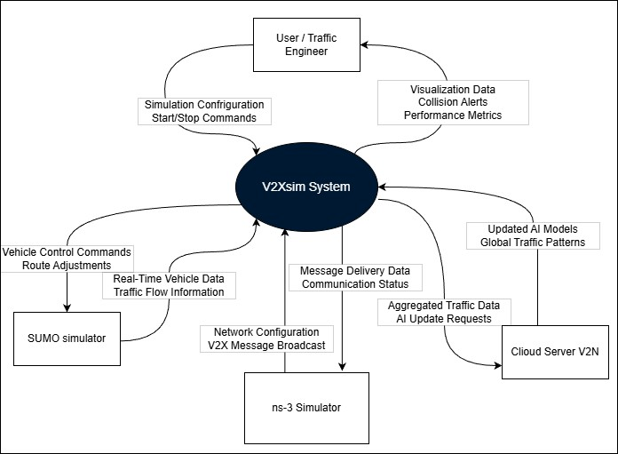

Definitions and Acronyms
Term / Acronym | Definition
V2X | Vehicle-to-Everything communication
V2V | Vehicle-to-Vehicle communication
V2I | Vehicle-to-Infrastructure communication
V2P | Vehicle-to-Pedestrian communication
V2N | Vehicle-to-Network communication
AI | Artificial Intelligence
SRS | System Requirements Specification
SUMO | Simulation of Urban Mobility traffic Simulator
Ns-3 | Network Simulator 3 for V2X Communication
TraCI | Traffic Control Interface linking SUMO and external systems
OBU | On-Board Unit (virtual vehicle node)
RSU | Roadside Unit (virtual infrastructure node)
V2Xsim | Project name for the V2X AI-Powered Communication Simulation
DeepCyan | Team name

References
Title | Author | Version | Date | Source / Location
Project  Proposal | Team  DeepCyan | 1.0 | 16/10/2025 | Please request a copy via email from the DeepCyan Team at: es660@uowmail.edu.au edj076@uowmail.edu.au
Planning and Feasibility Document | Team DeepCyan | 1.0 | 30/10/2025

1.7 Overview

This document defines the detailed system requirements for the V2Xsim, providing a foundation for design and implementation. It should be read in conjunction with the Planning and Feasibility Analysis document and the upcoming Design document.

Together, these documents ensure that the system is developed according to defined goals, technical standards, and expectations.

General Description

System Functions

The virtual platform demonstrates how connected transportation and infrastructure may work together to avoid collisions and ease congestion. Our system uses SUMO (traffic simulation), NS-3 (network simulation), and Python machine learning (ML) algorithms to run integrated scenarios.

Primary functions:

Simulate V2V and V2I communication.

Model real-time vehicle-roadside unit communication to analyze warning, braking, and routing.

Predict collisions and congestion with AI.

ML models can calculate collision probabilities and congestion risk from vehicle positions, speeds, and trajectories.

Configure and run scenarios.

Users can start/stop runs, set maps, traffic density, and simulation settings via a web dashboard.

Automate responses in the simulation.

The control software acts on AI outputs (SUMO force braking, NS-3 broadcast alerts, vehicle rerouting).

Visualise and record results.

Display alarms, performance metrics, and animated vehicle movement on the dashboard while storing logs for later analysis. These functions provide a cost- effective testbed for researching V2X behaviours without requiring real hardware.

User Characteristics

Our target are researchers, students, and developers working on AI for traffic systems, smart mobility, or V2X connections. Our platform makes educational application and experimental research more simple and easier for users.

User roles and expected skills:

Researchers / Developers: run experiments, modify models, and analyse system performance.

Students: use the environment for labs and demonstrations.

Urban planners / Analysts: test traffic management ideas in a virtual city. Typical technical knowledge required:

Basic Python (for ML and integration).

Machine Learning knowledge for model tuning and evaluation. Environment and access:

Accessed using a web client on standard desktops or laptops

Hardware is unneeded as sensors and radios are simulated.

Designed for both self-service use or otherwise guided research.

General Constraints

Software Constraints

This section outlines the limitations and mandated requirements related to the software tools,

libraries, and platforms used in the V2Xsim.

Open-Source Licensing and Compliance:

Constraint: The project is heavily reliant on open-source software (SUMO, ns-3, Python libraries, React.js, Docker). The team is constrained by the terms of their respective licenses (e.g., GPL, Apache 2.0). All usage must comply with these licenses, particularly regarding attribution and the distribution of any derivative works.

Impact: This constraint ensures zero licensing cost, which aligns with the project's goal of being an affordable testing environment. However, it requires careful management to ensure compliance if the platform is distributed publicly.

Technology Stack Interoperability:

Constraint: The core architecture necessitates integration between disparate software systems: SUMO (traffic simulation), ns-3 (network simulation), and Python (AI/ML & control). The TraCI API is the mandated standard for SUMO integration.

Impact: This dependency on specific APIs and data formats creates a technical constraint. Any changes or version deprecations in TraCI, ns-3's Python bindings, or the SUMO-ns-3 bridge could break the integration and require significant redevelopment effort.

Programming Language Standardization:

Constraint: The primary development languages are constrained to Python 3.10+ for the AI/ML, control logic, and backend (FastAPI), and C++ for components interacting directly with ns-3.

Impact: This ensures team productivity and leverages the extensive data science and web ecosystems of Python. However, it requires team members to be proficient in both languages, and performance-critical sections must be optimized to avoid bottlenecks.

Containerization for Deployment:

Constraint: The deployment strategy is constrained to using Docker for containerization. This is a preferred technical standard to ensure a consistent environment across development, testing, and demonstration phases.

Impact: This simplifies setup and dependency management but adds the overhead of maintaining Dockerfiles and Docker Compose configurations. It also assumes the target demo environment supports Docker.

3.2. Hardware Constraints

This section describes the limitations and requirements related to the computing hardware necessary to develop and run the simulation.

Simulation Scale vs. Computational Power:

Constraint: The fidelity and scale of the simulation are directly constrained by the available hardware, specifically CPU core count and RAM. The project specifies a minimum of 8-core CPU and 16 GB RAM, with a recommended 12-core CPU and 32 GB RAM for high-density traffic scenarios

Impact: This hardware limitation caps the complexity and number of concurrent

vehicles/infrastructure nodes that can be simulated in real-time. Exceeding these limits

will result in performance degradation, increased simulation latency, and an inability to accurately test the AI models.

Virtualized Development Environment:

Constraint: The initial development and demo approach is constrained to run within a single Virtual Machine (VM). The hardware specifications for this VM are fixed (8- core CPU, 16GB RAM, 50GB SSD).

Impact: This constraint promotes environment consistency and ease of setup but limits the team's ability to test large-scale scenarios during early development phases. Performance will be lower than on native hardware.

Absence of Specialized Physical Hardware:

Constraint: A core project constraint is the explicit exclusion of real-world V2X hardware (e.g., On-Board Units, Roadside Units, DSRC/C-V2X radios). All hardware functionality must be emulated in software.

Impact: This is a strategic constraint that makes the project feasible and cost-effective. However, it means the simulation cannot validate performance against real-world radio interference, physical sensor noise, or hardware-specific latency, potentially creating a gap between simulated and real-world results.

Assumptions and Dependencies

Assumptions

Data Fidelity

The project assumes that the data generated by SUMO and ns-3 is sufficiently realistic to train and validate the AI/ML models for traffic prediction and collision avoidance.

Model Generalization

It is assumed that the AI models, while trained on simulated data, will demonstrate principles and behaviours that are conceptually transferable to real-world V2X systems, even if not directly deployable.

Tool Stability

The project assumes the stability and continued support of its core open-source dependencies (SUMO, ns-3, TensorFlow/PyTorch) throughout the development lifecycle, without major breaking changes to their APIs.

Team Proficiency

The plan assumes that all team members possess or can rapidly acquire the pre-requisite knowledge in Python, C++, network simulation, and AI model design as outlined in the document.

Dependencies Software Dependencies

The project is critically dependent on the successful integration of:

SUMO for traffic micro-simulation.

ns-3 for network communication simulation.

The TraCI API for real-time data exchange between SUMO and the control software.

Python ML Libraries (TensorFlow/PyTorch, Scikit-Learn) for developing the predictive analytics module.

Data Dependencies

The system depends on the availability of well-defined map files (e.g., from OpenStreetMap) and traffic demand data to create meaningful simulation scenarios. The quality of the simulation outputs is dependent on the quality of these input files.

Performance Dependencies

The ability to run large-scale simulations and achieve low latency between simulators is dependent on having access to hardware that meets or exceeds the "recommended" specifications.

Knowledge Dependencies

The project's progress is dependent on the team's collective ability to overcome the documented challenges, particularly the synchronization of SUMO and ns-3 and the design of efficient, non-blocking ML models.

Functional Requirements Master List Functional Requirements Table
Req.  ID | Requirement Name | Requirement Description
REQ  1 | Simulation  Configurator
REQ 1.1 | Simulation Parameter Configuration | The system allows users to define parameters that will be used for the simulation via a web client.
REQ 1.2 | Simulation Session Starter | The system allows users to begin a new simulation via web client.
REQ  2 | Simulation Initializer
REQ 2.1 | Simulation Asset Loader | System retrieves pre-defined vehicles, routes, AI model, and other necessary data from storage.
REQ 2.2 | Simulation Software Configuration | System configures simulation software based on information provided via data retrieval.
REQ  2.3 | AI Model Startup | System loads AI model data into the interpreter.
REQ  3 | Simulation
REQ 3.1 | Mobility Simulator | System executes SUMO software to simulate traffic data along pre-defined data.
REQ 3.2 | Network Simulator | System executes NS-3 to simulate V2X communication between vehicles and infrastructure.
REQ  3.3 | Simulation Cross-  Communication | System passes data from SUMO into NS-3.
REQ  4 | AI Data Interpreter

REQ  4.1 | Data Input | System passes data to AI interpreter from simulation  software.
REQ 4.2 | Collision Prediction | Data interpreter identifies vehicles on crash collision course and outputs probability of impact occurring and time for collision to occur.
REQ  4.3 | Traffic Congestion  Prediction | Data interpreter analyzes traffic flow and outputs  probability of congestion occurring.
REQ  5 | AI Intervention
REQ  5.1 | Collision Avoidance | Based on AI interpreted data, system will inform  vehicles in SUMO software of measures to take to avoid crashing.
REQ  5.2 | V2X Crash Alert | Based on AI data, system will inform nearby cars of  collision via warning message using NS-3.
REQ  5.3 | Traffic Congestion  Reduction | Based on AI data, system will adjust routes and traffic  infrastructure to lessen congestion.
REQ  6 | Data Management
REQ  6.1 | Simulation  Configuration Data Storage | System stores configuration data in specified data storage  location.
REQ 6.2 | Simulation Result Data Storage | System stores results of simulation in specified data storage location.
REQ  7 | Data Display
REQ 7.1 | Simulation Data Retrieval | System lets web client retrieve simulation data via gateway.
REQ  7.2 | Animation Display | Web client dashboard displays movement of vehicles.
REQ  7.3 | Traffic Flow Display | Web client dashboard displays traffic flow.
REQ  7.4 | Warning Display | Web client dashboard displays warning messages for  collisions and congestions.

REQ  7.5 | Performance Display | Web client dashboard displays performance statistics of  simulation.

Functional Requirements REQ-1: Simulation Configurator

Description

The Simulation Configurator enables users to define all parameters needed to run a V2X simulation, including the number of vehicles, road map, simulation speed, traffic density, environmental signs, and AI settings.

System Input

User-defined parameters entered via the web interface: Vehicle count (≤ 200), Map file (SUMO .net.xml), Simulation duration and speed (real-time or accelerated), Traffic signal data, and AI mode toggle.

Display

Configuration form on the ReactJS dashboard showing input fields, dropdowns, Save and Start buttons, and a preview pane of selected map.

System Processing

System validates inputs, stores them temporarily, and creates a JSON configuration file after the operator presses Start Simulation.

System Output

A validated JSON configuration file is generated and stored locally and in the PostgreSQL container with a unique timestamp.

Other

All configurations are version-tracked with user and time metadata.

Constraints

Limited to 200 or less active vehicles and map files below 50 MB.

Data Handling

Configurations stored as UTF-8 JSON. Parameters validated for numeric ranges and file integrity.

Error Handling

None

REQ-2 Simulator Initializer

Description

Initializes the environment, loads assets, and synchronizes SUMO, ns-3, and the AI model.

System Input

Triggered by pressing Initialize Simulation button.

Display

Progress indicators: loading vehicles, starting SUMO, ns-3, and AI model.

System Processing

Control software retrieves configurations, launches SUMO/ns-3 via TraCI, syncs them, and loads the AI model.

System Output

System readiness message and configuration log file.

Other

Initialization progress can be monitored via UI log feed.

Constraints

All simulators and AI modules must run inside Docker containers on Ubuntu 22.04.

Data Handling

Session configuration cached until simulation ends.

Error Handling

Failed launch retries 3 times; fatal errors reinstall packeages. REQ-3: Simulation

Description

Executes synchronized SUMO and ns-3 simulations in real time or accelerated mode.

System Input

Inputs from REQ-1 configuration and REQ-2 initialization.

Display

Dashboard shows vehicle motion, signals, network data, and speed slider.

System Processing

SUMO simulates traffic, ns-3 handles communication, TraCI bridges both, Python orchestrator synchronizes clocks.

System Output

Vehicle and network data logs in CSV/JSON and visual stream.

Other

Simulation duration adjustable mid-run via control panel.

Constraints

Supports 200 vehicles; cap for demo.

Data Handling

Vehicle and network metrics logged with timestamps.

Error Handling

TraCI drop triggers pause and reconnect; persistent failure stops simulation.

REQ-4: AI Data Interpreter

Description

Interprets simulation data to detect collisions and congestion using ML models.

System Input

Data from simulation: positions, velocity, heading, latency, queue sizes.

Display

AI status panel with congestion heatmaps and collision indicators.

System Processing

Random Forest for interpretability and low latency; MLP for complexity; XGBoost for scalability. Runs inference only on local pre-trained models.

System Output

Outputs JSON packets with collision probability, time-to-impact, congestion index.

Other

Model version and parameters logged for reproducibility.

Constraints

Accuracy limited by simulation fidelity; inference ≤ 2 Hz per vehicle pair.

Data Handling

Results cached and flushed every 10s to PostgreSQL.

Error Handling

Model load failure triggers fallback rule-based system and alerts operator.

REQ-5: AI Intervention

Description

Implements AI-driven responses to prevent collisions or reduce congestion with operator override.

System Input

AI outputs and operator commands from dashboard.

Display

Dashboard options: Approve, Reject, Request Alternate Action.

System Processing

High collision risk: deceleration/reroute commands sent to SUMO, warnings broadcast via ns-

3. Overrides logged.

System Output

Actions logged and reflected in SUMO/ns-3; operator decisions stored in DB.

Other

Full traceability maintained between AI, operator, and results.

Constraints

AI-to-SUMO update latency ≤ 1s.

Data Handling

Actions timestamped and linked to session ID.

Error Handling

Communication failures retried twice; operator alerted on failure. REQ-6: Data Management

Description

Handles storage, retrieval, and versioning of configuration and simulation data.

System Input

Data streams and configuration objects from modules.

Display

Database status indicator and saved session logs.

System Processing

PostgreSQL manages structured storage; JSON/CSV files archived; metadata appended; auto- versioning enabled.

System Output

Persistent records of configurations, AI results, operator actions, and metrics.

Other

Backups directory.

Constraints

Storage limited to 20GB; oldest logs auto-purged.

Data Handling

timestamps.

Error Handling

On DB failure, local cache retry every 5 minutes for errors.

REQ-7: Data Display

Description

Provides real-time visualization of simulation data, AI predictions, and performance metrics.

System Input

Data retrieved from PostgreSQL and WebSocket feeds via FastAPI.

Display

Interactive dashboard with maps, charts, heatmaps, and alerts.

System Processing

FastAPI streams via WebSockets; ReactJS renders updates; operator commands sent to backend.

System Output

Visual reports, screenshots, and downloadable summaries (PDF/Excel).

Other

Dashboard adjusts refresh rate based on latency.

Constraints

≤ 7 concurrent users; 1s WebSocket interval.

Data Handling

Uses cached data; visualizations built with Plotly.js/D3.js.

Error Handling

If WebSocket fails, the system switches to HTTP polling and alerts the operator.

External Interface Requirements

Data Interfaces
Interface Name | Description | Data Format | Protocol/Method
Simulation Configuration Interface | This interface inputs the initial simulation parameters like amount of traffic, vehicle routes, map  files. | .net.xml (SUMO network), .rou.xml (SUMO routes), JSON/YAML  config files | Files are uploaded through Web Client; API (REST)
Inter-Simulator Synchronization Interface | Data is exchanged in real time between SUMO traffic simulator and the NS-3 network simulator for coordination of V2X communication and vehicle  mobility. | TraCI Protocol Messages, Custom Socket Data | TraCI (TCP),  Custom Socket Connection
AI Analytics Data Interface | This is the interface for the Data Interpreter Module, it obtains vehicle telemetry in real time (like the location, path, speed) and then provides predictions (like collision and traffic  chances) | Structured Data Frames (Pandas), JSON | In-process Python function calls, Inter- Process Communication (IPC)

Results Storage &  Retrieval Interface | This is the interface for  storing the simulation output data (like vehicle path, records of events, performance) and for access to visualize and analyse. | JSON, CSV,  Time-Series Database Format | Database Queries,  REST API Calls

User Interfaces

Interface Name | Description | Technology
Main Simulation Dashboard | This is a primary GUI for allowing users to set simulations, initiate runs and analyse results in real time. | React.js, HTML5, CSS3, JavaScript
Simulation Control Panel | This is a specific panel inside the dashboard for start, pause, stop and to reset simulations. | React.js Component with REST API backend (FastAPI)
Real-Time Visualization Canvas | This is a graphical and animation that displays vehicle motion on map, traffic flow, and warns any traffic accidents or jams. | React.js integrated with visualization libraries (e.g., D3.js, Leaflet)
Analytics & Reporting Dashboard | This is an independent section dedicated to showcase structured data, performance, charts, graphs and logs from simulation. | Grafana Dashboards, Custom React Components with Matplotlib/Plotly

Other Interfaces

Interface Name | Description | Type | Protocol
Version Control System Interface | This interface manages the source code, team collaboration, and integrating CI/CD pipelines. | Software Platform Interface | GitHub API / Git Commands
API Gateway Interface | This is a single-entry point that routes all of the external requests from the Web Client to the right backend services like data storage  and control software. | Software Interface | HTTP/REST via Nginx or FastAPI

Virtual V2X  Hardware Emulation Interface | This simulation platform will  emulate the real world V2X hardware interfaces using software. Including OBUs, RSUs, and communication within NS-3. | Software  Emulation | NS-3 Network  Models, SUMO Vehicle Agents
Container  Orchestration Platform Interface | This is the interface with the  container orchestration system that handles deployment, scaling, and the networking of microservices like SUMO, NS-3, API,  Dashboard, AI Model. | Software  Platform Interface | Kubernetes -API (if  used on GKE/EKS/AKS)

Non-Functional Requirements

System Performance
Req. ID | Description | Target / Response Time
PERF-  1.1 | Operator latency when navigating dashboard components  (e.g., switching tabs, viewing charts). | ≤ 1 second
PERF-  1.2 | Initiating a new simulation or applying updated  configuration parameters. | ≤ 3 seconds
PERF-  1.3 | Executing medium-complexity simulation runs (≤ 500  vehicles, moderate network size). | ≤ 7 seconds startup time
PERF-  1.4 | Full integration run between SUMO and NS-3 with real-  time AI inference. | Real-time data sync  latency ≤ 200 ms
PERF-  1.5 | Dashboard visualization refresh rate during simulation  playback. | ≥ 10 frames per second
PERF- 1.6 | System throughput for simulation logs and AI outputs. | ≥ 5 000 records per minute

The system should run smoothly and update in real time so users can see what’s happening without delay. Using Docker and cloud tools helps manage resources better and keeps everything consistent between runs.

Information Security
Req.  ID | Description
SEC- 1.1 | All data exchanges between Web Client, API Gateway, and back-end services must occur over HTTPS/TLS 1.3.
SEC- 1.2 | Simulation and user credentials are stored using salted SHA-256 hashing and role- based access control.
SEC- 1.3 | No personally identifiable information (PII) or external live sensor data shall be collected or retained.
SEC- 1.4 | Docker containers must isolate workloads to prevent cross-service data leakage.
SEC-  1.5 | API keys and environment variables must be stored in encrypted Kubernetes Secrets.
SEC-  1.6 | The platform shall comply with institutional data-protection guidelines and open-  source license terms.

Because this project is for research and learning, the main goal is to keep everything private,

secure, and separate. Using encryption and container security makes sure no one can access

another part of the system by mistake.

Availability
Req. ID | Description
AVA- 1.1 | System should be operational > 90% during demonstrations and scheduled evaluations.
AVA- 1.2 | Docker/Kubernetes orchestrator will automatically restart failed services within 30 seconds.
AVA- 1.3 | System checkpoints allow paused/resumed simulations without data loss.

The project should always be available when needed for testing or demos. If something goes wrong, the containers or services restart automatically so the team doesn’t have to fix it manually.

Capacity
Req.  ID | Description
CAP-  1.1 | The system should handle small-scale simulations of around 50–200 vehicles and  10–20 roadside units.
CAP-  1.2 | Each simulation run may generate up to 1–2 GB of log and result data.
CAP-  1.3 | The system should maintain smooth performance even during longer (10–15 minute)  simulations.
CAP-  1.4 | The project setup should run comfortably on a standard laptop or VM (8-core CPU,  16 GB RAM).

Capacity figures derive from the project’s defined hardware baseline (8-core CPU / 16 GB RAM minimum, 32 GB recommended). Scaling is achieved horizontally through Kubernetes node pools, ensuring predictable performance for educational and research usage.

